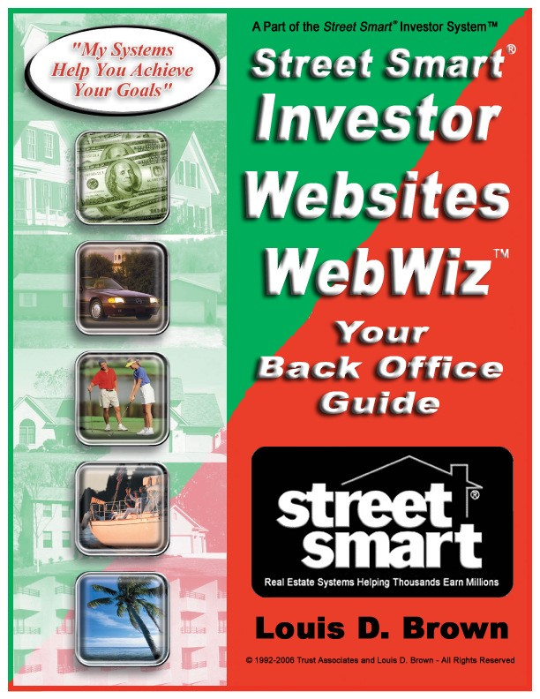

IMPORTANT NOTICE

THIS IS COPYRIGHTED MATERIAL SUBJECT TO THIS COPYRIGHT NOTICE
Anyone reading or reviewing this work will recognize the thousands of hours of research, application, testing and review it took to create the concepts, training, instruction and documents contained in this manual. Please respect this investment.
This Street Smart® WebWiz™ Guide training manual is provided to owners of StreetSmartInvestorWebsites.com websites for their exclusive use and with the understanding that neither the Author nor the Publisher is engaged in rendering legal or accounting services. Neither Louis D. Brown nor Bruce Beasley is an attorney or an accountant. Questions relevant to specific tax, legal, and accounting needs of the reader should be addressed to practicing members of those professions.
The information, ideas, and suggestions contained herein have been developed from sources, including publications and research, which are considered and believed to be reliable but cannot be guaranteed insofar as they apply to any particular person's tax situation. Moreover, because of the technical nature of the material covered herein and the dynamic nature of the laws governing our actions, the assistance of a competent, qualified attorney, financial planner or accountant is highly recommended when implementing any concept discussed in this work.
The Authors specifically disclaim any liability, loss, or risk, personal or otherwise, incurred as a consequence directly or indirectly of the use and application of any of the techniques or contents of this guidebook or any related audio, video or live training.
Thank you for your respect and support. We invite suggestions and appreciate testimonials from anyone who uses these concepts and tools.
THE COPYRIGHT HOLDER LICENSES YOU AND ONLY YOU, as the sole owner of a
StreetSmartInvestorWebsite.com website to use the information contained herein for personal use only as a reference training manual. Any reproduction or use of these documents by anyone will be prosecuted to the fullest extent allowed by law. Please respect the thousands of hours invested to research and create this work and our rights to this material. Govern yourself accordingly.
All Rights Reserved.
No part of this training manual may be reproduced, stored in any information retrieval system; transmitted in any form
or by any means, or transferred to any third party without the specific written permission of Trust Associates and Louis D. Brown.
© 1992-2019 Trust Associates and Louis D. Brown
4426-B Hugh Howell Road, Suite 200, Tucker, GA 30084 Phone: 770-939-8283 Fax: 770-939-3177
Web Site: https://streetsmartinvestor.com E-mail: support@streetsmartinvestorwebsites.com
Welcome to your Street Smart® WebWiz™ Guide
Congratulations! You’ve made a wise decision to add Street Smart® Technology to your business plan. As you will see, we’ve helped you use your Street Smart® Tools in conjunction with our Technology to help you build your business faster, safer and for much less cost than if you tried to design it on your own. As we’re sure you’ll agree, these business tools are well thought through and are very user friendly. Designed by investors for investors, these sites use the copyrighted system of Louis “Lou” Brown. You’ll probably recognize that many of the paper systems included in your written Street Smart® volumes have come to life in these Buying and Selling Websites.
Your Buying and Selling websites will provide you Public Credibility and Lead
Generation. Your “Seller Presentation Kit” is brought to life on the public side of your
Buying site. Your “Buyer Presentation Kit” is brought to life on the public side of your
Selling/Renting site. Your lead management and marketing tools included in your Buying and Selling volumes have been made interactive and dynamic in your “WebWiz™” back office management system.
Your Street Smart® WebWiz™ will become the way to efficiently manage your leads along with many other features we’ll discuss here. Combined, this will give you the right solution to your basic real estate technology needs.
Public Site- Your buying public site is very user friendly and is designed to answer many of the questions your sellers, buyers, and renters will have. This will make you look very professional and have you appear to be a multimillion dollar company. It also gives the seller a place to answer all of the really important questions you need details on to create an offer. Tour the public site on your own as the uses and benefits should be self-explanatory.
This tour focuses on your Back Office. We call your private Back Office “WebWiz™.” WebWiz™ will allow you to objectively evaluate leads generated through the public site exposure and others you find through other marketing methods. Now let’s get started on your Street Smart® WebWiz™ Back Office tour!
Step 1 – Set Up Your Domain Name
Before we set you up with a website, we need a domain name for you. That’s your own address on the World Wide Web. We need one for each of your buying, selling, and lending websites. Unless you’ve already selected one, you are probably thinking “What kind of name should I use?” That is a common question. Let’s give you a few hints. You can choose to be creative. One student has sackmylandlord.com, or you can use your company name alone or with homebuyers / home sellers or buys houses / sells homes after it. You can also use your geographical region such as:
www.TriStateHomeSellers.com, metroatlhomebuyers.com. When deciding your name, just keep in mind that the website name has to fit on a sign, business card, or ad in a newspaper. We recommend keeping your name under 25 characters. To check if a domain is available, you can go to http://www.streetsmartinvestordomains.com/, click on the text box where it says: ‘Enter a Domain Name:” and insert your possible name and click search. When the page loads it will tell you if your name is available and give you some options. If you have not already purchased your domain names, you can do it here for $12.99 per year, per name reserved.
Step 2 – Point Your Domain Name Server (DNS) Settings
Once you have purchased your domain names, the Name Server setting needs to be set to point to our server where your websites reside. To change your current DNS settings, click on “Manage Account”, then click on “Manage Domains”. Select the domain names that you are changing the settings of then click on “Name Server Settings”. On the right you should see a place to type in your new settings. Please change each domain name to both ns1.streetsmartinvestorwebsites.com and ns2.streetsmartinvestorwebsites.com. Be sure to click “Save Changes”. If you don’t, your website(s) won’t be found. Try it, it’s easy. If you have any problems, we can do it for you- just email us or give us a call with the username and password for your domain account and tell us where you purchased the domains. We’ll take it from there and send you an email when it is done. By the way, as we are often on the phone making outbound setup calls, it is highly recommended you communicate with us by email. This often gets you a quicker response time.
Step 3 – Fill out your Setup Web Form
Please fill out Street Smart® Setup Form at http://streetsmartinvestor.com/websitesetup/.
If you are licensed both, Buying and Selling websites, you will need to purchase two different domain names.
In addition to domain, we recommend creating an email. This allows you to appear more professional – which gives you more credibility. It is a web email account similar to GMail™ and is hosted on our servers. An example of what your email would look like is You@YourDomainName.com. Any domain name you wish to use for your email account must be owned by you. We suggest you use the one you setup for these websites.

We tried to make the setup form easy as possible. However if you have any questions, please email Support@StreetSmartInvestorWebsites.com or call.
Step 4 – Submit Setup Sheets to Us
After the Street Smart® Setup Web Form filled out, click on “Submit” button. We will instantly receive your website access request. As soon as this is input, your websites will be up within 2 days (usually less).

Yeah Baby! Your websites are up!!
Once your websites are up, check the public side to make sure all your contact information is correct. We also recommend you test the sites by filling out all the forms the public will fill out. This will give you a feel for the system and how it works. Having done that, it’s now time to check out where that data went.
Step 5 – Check out your Street Smart® WebWiz™ Back Office
To login to your back office go to https://streetsmartinvestorwebsites.com/ss-login/ BOOKMARK THIS PAGE. As you will use this page to login each time you visit your site. In the beginning this may be daily. Some of our power users login several times per day to manage their leads. Type in the user name and password provided to you. Once on the main page, take a look to see what is there. Explore all the links on the left hand side of the page. The top link is “Account Info”. Click there to change anything on your website- your contact phone numbers, company name, email where notifications get sent, and most important, your theme. Once you change anything, make sure you click UPDATE on the bottom of the screen. ** Changes you make on one site DO NOT transfer to the other site. You will need to change each site (buying, selling, and lending) yourself.
Step 6 - Email Login
To login to your webmail account, https://streetsmartinvestorwebsites.com/webmail. BOOKMARK THIS PAGE, too! As this link will provide you access to your emails. Your user ID is your WHOLE email address: you@yourdomainname.com and then your password provided to you. If you have any questions, email us at Support@StreetSmartInvestorWebsites.Com or call.

Welcome to your Street Smart® WebWiz™ FAQ’s
- My websites are up - now what?
Start marketing!!! This is critical. Get your website out there! This is the single most important item needed to build your business. To see our recommended buying and selling marketing materials click the “Resources” folder, found in your Back Office WebWiz™ “Document Library” page. Your marketing should always include your buying or selling website address depending on the type of marketing you are doing. You will also use your websites to load leads from other sources so you can manage the lead and follow up from there. You will get occasional “leads from the sky” (folks surfing the web) but do not depend on these. They are often not from your area. Remember, your public websites are primarily a credibility tool and a place to gather information from leads who visit the site. The WebWiz™ is your online office used to manage these leads, both buying and selling leads.
- How do I load my current leads to WebWiz™?
To load your current leads, go to the public site and fill out the questionnaire.
That will load your leads into your online back office. Explore your website and find out how it works front and back. Don’t forget to add testimonials and properties.

- How do I change my theme (graphic design appearance)?
If you haven’t already done so, change your theme to fit your business and you Starting from the main page of your back office, click “Account Info”. Scroll down to the bottom of the screen. Under Keywords and Description you’ll see “Website Theme”. You have over 6 color choices to choose from. Click that link to the right of the pull down menu to preview what the themes look like. Just be sure to change the theme in the drop down menu before clicking “Update”. **Note- the back office theme does not change, only the public side will.
- How do I upload Testimonials?
From your WebWiz™ main menu on the left hand side choose either Buying or Selling page, click on “Add Testimonials.” From there it takes you to the page where you can manage all your testimonials. Since you have not added any, it will say click here to add a testimonial. At the top of the screen where you are going to add your testimonial, be sure to click the Testimonial Switch “ON”. Then fill in what the clients have said about you. You can also add a photo of your clients or their house. If you don’t have any testimonials, email us and we can add some for you. Just tell your clients “here are testimonials of colleagues of ours.”

- How do I upload a property onto my Selling site?
Starting from the “Dashboard,” click on “Selling (You are selling).” Located from the main menu. Next, click on “Properties” and finally choose “Add Property”. Fill out ALL the information for the property then scroll to the bottom of the screen to upload any photos of your property. To ensure the property to appear on your website, ensure “Property Switch” is set to “ON.” Finally, click on “Submit”.
- How do I access my Street Smart® Lou Brown Paperwork?
From the WebWiz™ main page, click “Document Library” on the left. If the volume name is in grey, you have access to the paperwork. You will only have access to the volumes you have purchased through Street Smart®. If you own a volume and you cannot access the paperwork, click the “Verification Form” link at the top of the page. Check the boxes that need to be turned on and click “Send”.
- How do I add a Free Report?
From the WebWiz™ Buying Lead Mgmt or Selling Prospect Mgmt menu, click the “Free Report Follow-Up” tab. At the bottom of the page, click on “Manage Free Reports” button. You will be directed to “Manage Free Reports” page. By default, there is a single report already upload for you! To turn on the report, check off the Activate box.
If you would like to upload one of your own reports, type the report title of the free report and click on “Browse” button to find the file on your computer. When you have found the file, click “Open” and then click “Add”. If successful, the report will appear toward the bottom of the page. Don’t forget to check “Activate” box to have your report live on the public side.
You can upload Microsoft Word, Word Perfect and Adobe Acrobat files. There is no limit to the number of free reports you can have. If you own Richard Roop’s Marketing Magic you may upload his free report. You can also customize your own report and even add details about your company and photos of yourself.
- Where do I go for additional assistance?
Explore your website and find out how it works front and back. For additional help and support, please call 770-939-8283 or email Support@StreetSmartInvestorWebsites.Com.

Your Street Smart® Investor Buying Website Tutorial
Once you have logged in, you will either be taken directly to your Street Smart® WebWiz™ BackOffice. You will see a “Welcome” message on the left with several links in bright blue on the left-hand side of the page. This is known as the “Navigation Menu”. These links can direct you to the other interactive pages of the website, so you can navigate more easily.
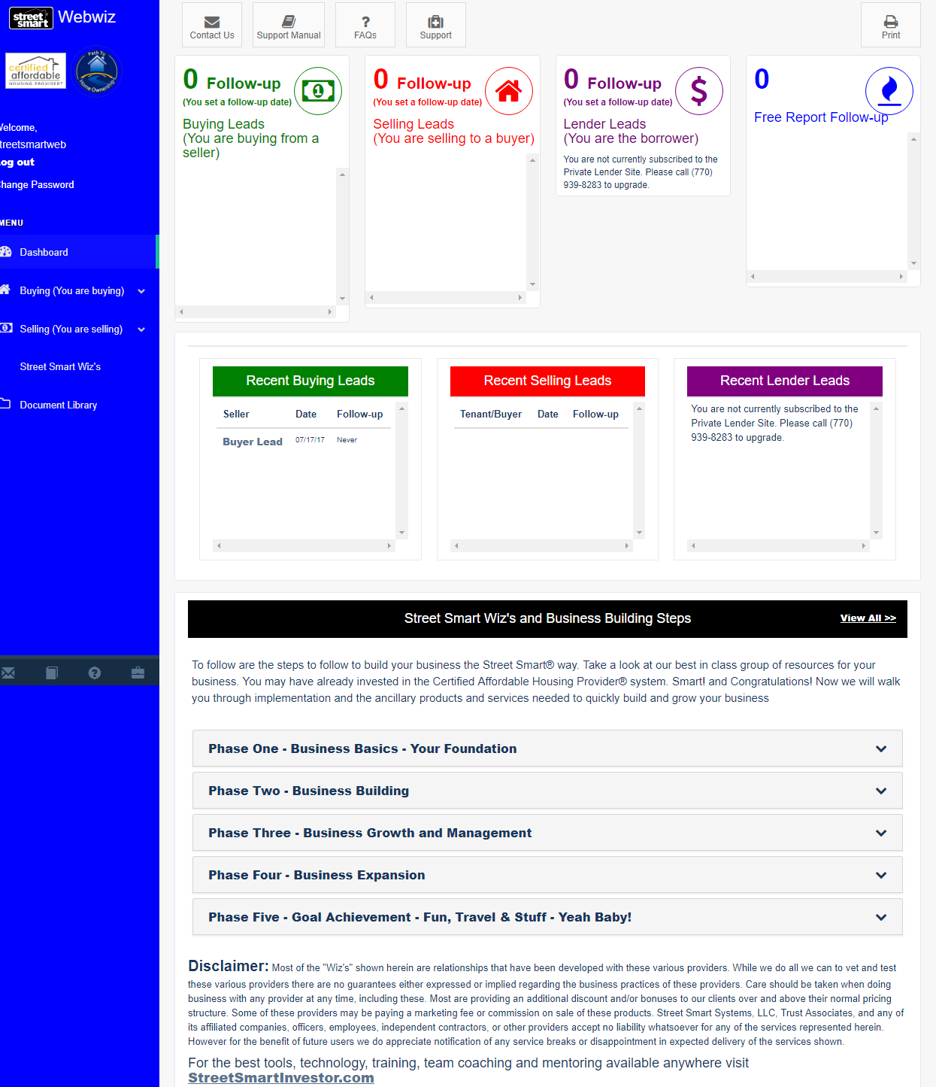
“Follow-up (You set a follow-up date)” on the right side of the page. Also referred to as the “Dashboard” page, provides a bird’s eye view of all your leads.
Please click on the “Buying (You are buying)” from the Navigation Menu and choose the first link, “Home Buyer.”

This is what you should see:
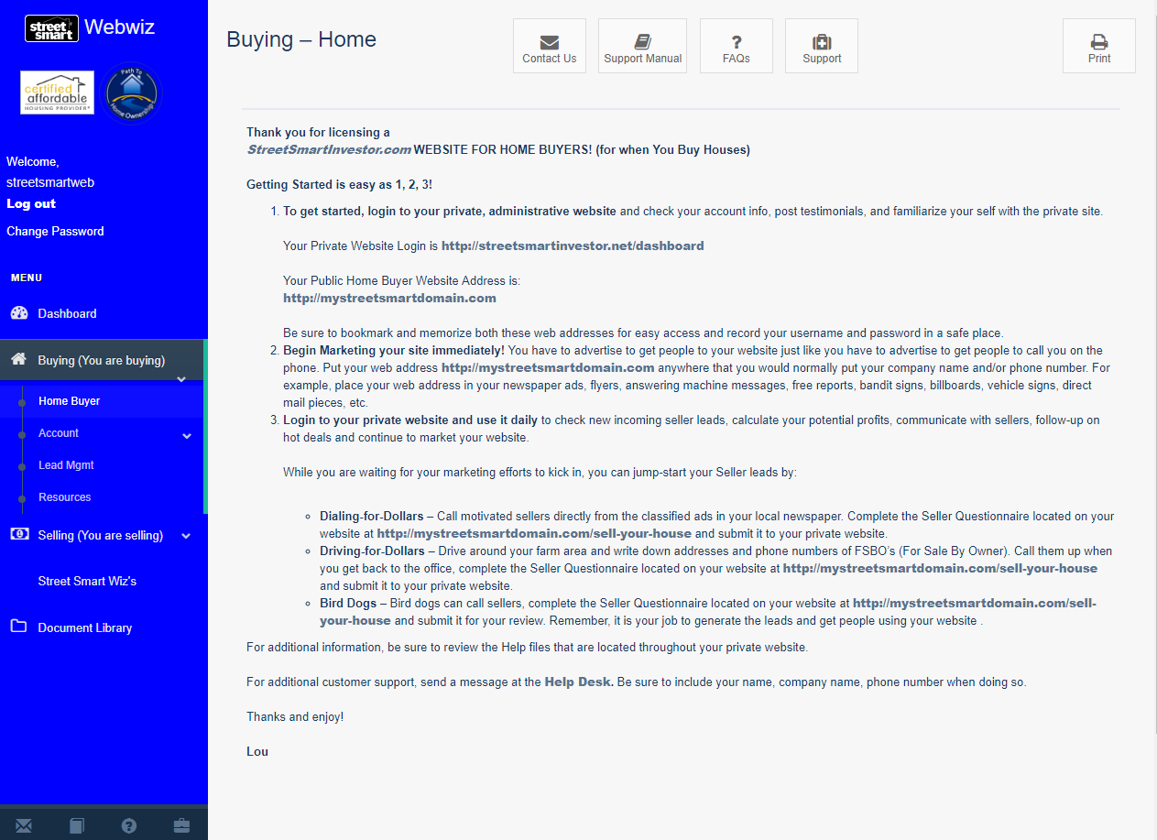

Account Management
Let’s proceed by clicking on next link, “Account.” Once you have clicked on “Account Management,” your screen should look similar to this:

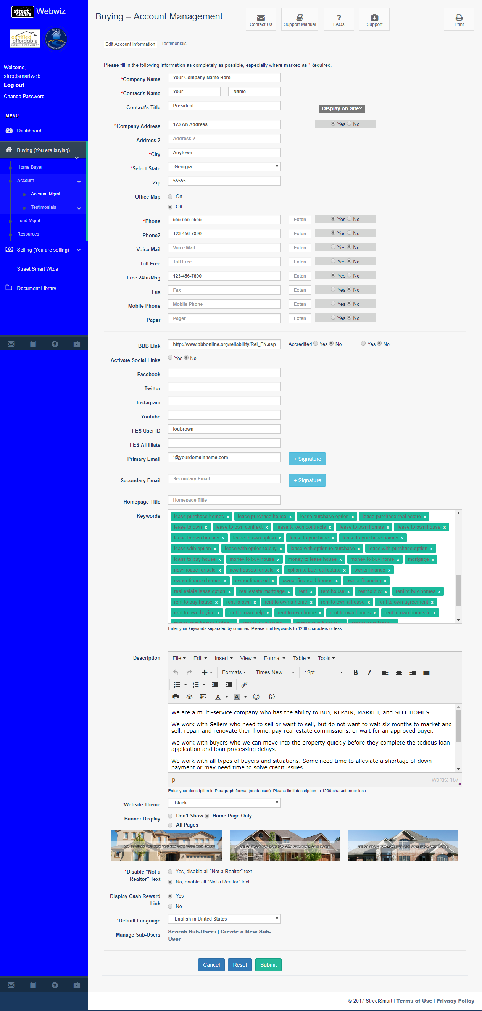

This is where you edit your company information and decide if you want to make it available for exposure on your public side. ** Note- Making changes on one site DOES NOT reflect on the other site(s). *** You will need to make your changes there as well.

Notice there are two spaces for emails, primary and secondary. The primary and secondary email fields should reflect where you would like all future leads and notifications to appear. The public cannot see your email address, but can get in touch with you by clicking on “Contact Us” link. Which will send a message directly to your email.

Account Management Page Item Descriptions:
Keywords – These are words search engines such as Google, Yahoo, or MSN pull from to find your site. We preload keywords that we know work, but you are welcome to modify or add words if you like. We recommend adding your city or areas where you are, or will be working.
Website Description –This is the little blurb that appears beneath the link when you use a search engine. Again, we’ve preloaded this for you.
Website Theme & Banner –This is where you change your graphic design theme.
To see the different themes we offer, click on the drop-down menu and select a color.
There are currently six colors to choose from. Please review all of our themes to see which one best suits your location and/or your business.
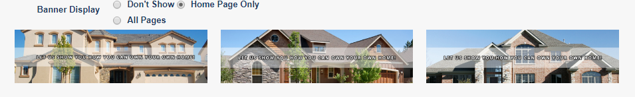

Banner Display is another feature to impress and promote your brand. This is what the public side of your site will look like if you choose this theme. Keep in mind that your WebWiz™ Back Office theme will remain the same and does not change.
Realtor® Text – This option, also on this page, is located directly below the Website Theme area. This allows you to select “Realtor friendly” text. Choose the version best for your situation, then click “Submit.”
Once you have decided on your theme, banner and realtor® text, scroll down to the bottom of “Account Info” page, and click on the “Update” button.

Seller Follow-up Log
When you click on the “Lead Mgmt” link, you will view a page that looks like this:
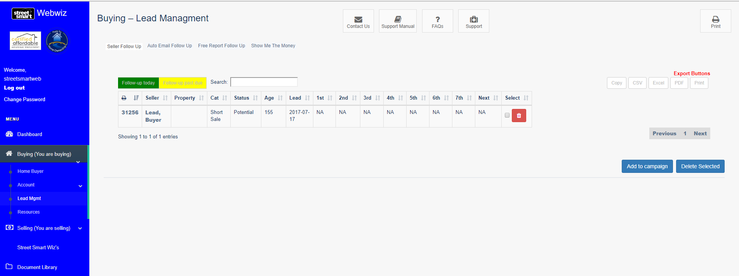
This is where your Buying-Leads will be stored. Once someone fills out and submits a questionnaire on the public side the lead will appear here. You will be able to sort your leads alphabetically, by property, by potential profit, or by follow up. Just click on the appropriate word to sort.
Notice that some of the names can be highlighted in green and some in gold. The green stripe means you previously set your follow up and today is the day for follow up. Green means “Go”. The Gold indicates that it has passed your selected follow up date. The “Gold” is in the follow up! Don’t let that lead go! Also set follow ups thereafter until you get the deal or it gets sold.
**Note- When you get your first few leads; there is a good chance that the email will be caught by your spam filter. You will need to white list the email address, noreply@streetsmartinvestor.net. This will insure all leads emails arrive directly to your inbox.

Click on either the lead name or property address to be transferred to “Seller Questionnaire.” This will allow you to review the specific questionnaire and their answers.

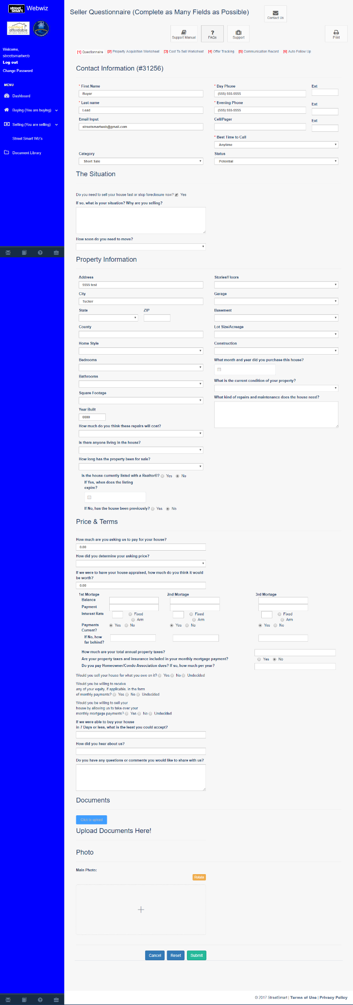
This page contains all of the seller’s information. If they didn’t answer every question, as you are talking with them, you can finish filling this out and save the new information by clicking “Submit.” You can also add a picture of the property to the lead to help you remember what it looks like. This is quite handy when you have to follow up over a period of time.

You can go to the “[2] Property Acquisition Worksheet” by clicking the tab at the top of the page. Your page should look like this:

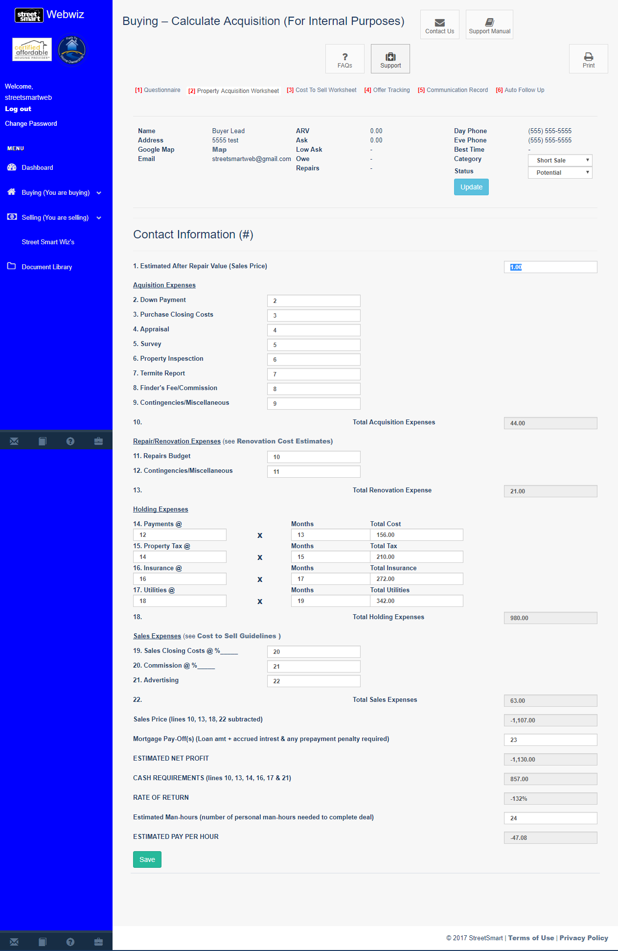
At the top you’ll see some information from the questionnaire is automatically preloaded to save you time so you can see details at a glance. This means you won’t constantly be going back and forth for reference. Is that a time saver or what? The rest of the page is your worksheet calculator. This helps you determine how much profit you will make on the property and if you should go for it. Just fill out all the boxes and click “Calculate”. Once you click Calculate, you won’t have to fill out this information again. This is saved to this property. Your estimated profit will now appear in the Seller Follow-up Log under the money sign “$” column. This property will now show up under the “Show Me the Money” link. We’ll visit this a little later.
The next page helps you keep track of your offers, or potential offers related to this property.

To the select “[4] Offer Tracking,” simply click on the tab at the top of the page.

Just write your offers and exit strategies in the corresponding box and click “Submit”. Beneath those two boxes you can create and view multiple scenarios for this particular property. Again you should notice the property information at the top. You should craft several potential offers before visiting the seller.

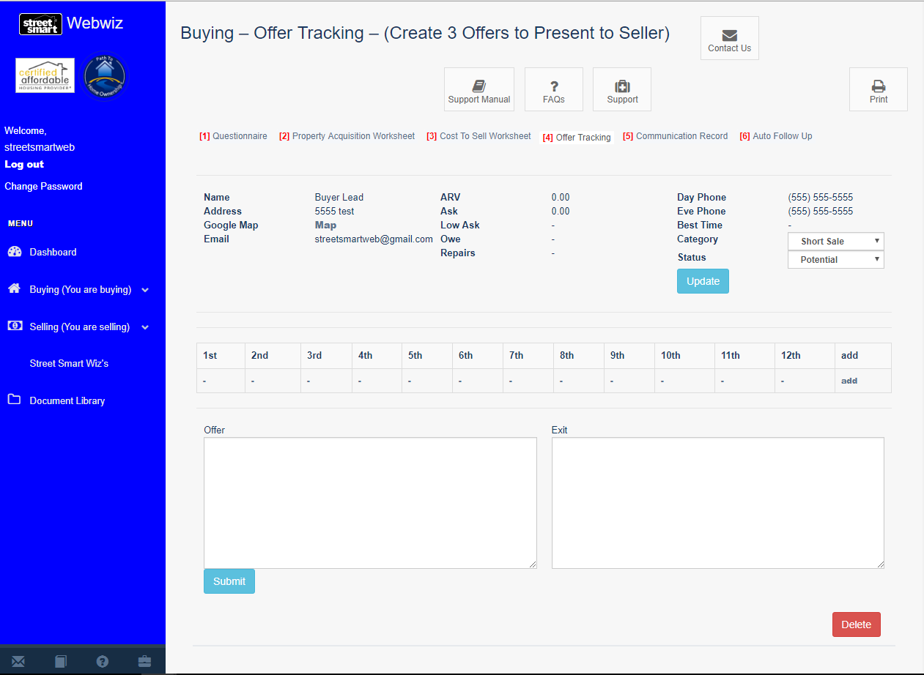

To keep track of your communications with the seller, you’ll click the “Communication Record” tab, at the top of the page. The page should look like this:
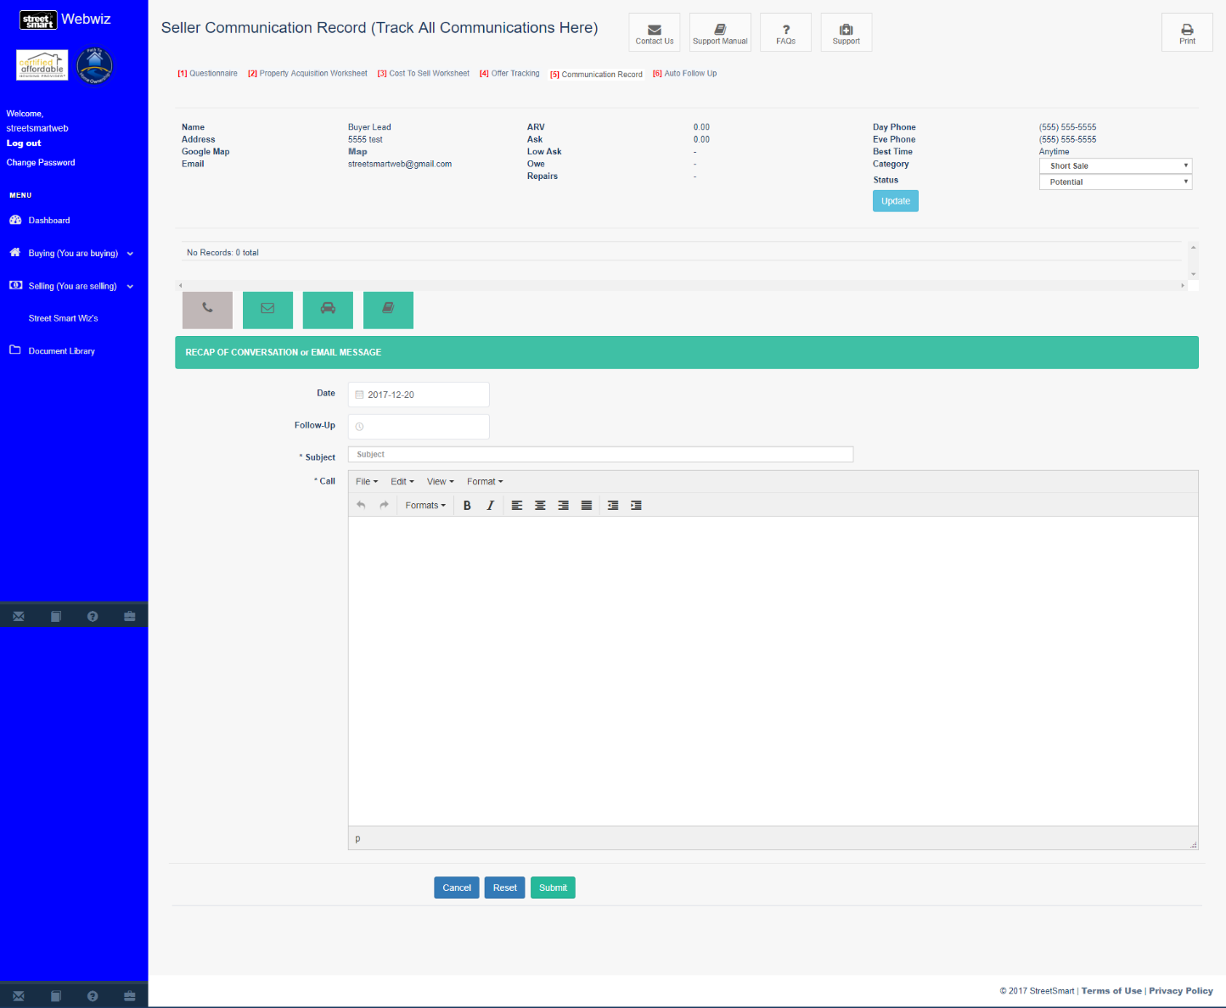
This page allows you to have a paperless office. Here, you or your staff can recap any conversations here. In addition, this is where you set your follow up dates.

There are four icons to choose from:
- Telephone (use this icon to document follow up phone calls made)
- Mail (click on this icon when sending an email directly from this page)
- Vehicle (a great icon to use when out in the field or meeting up with client)
- Note pad (click on icon for general notes)

As you will notice, your communications are saved above the Recap Communication field. This also allows you to make a note and set no follow up date. It’s a great way to keep all of your conversation notes in one place and you can access them anytime, anywhere, from any computer. If you run an office with employees, this is a great way to see how they are progressing on a deal if you are not directly working on it yourself.

Next step would be to visit the “Show Me the Money” page. When you click the link, you will be taken here:
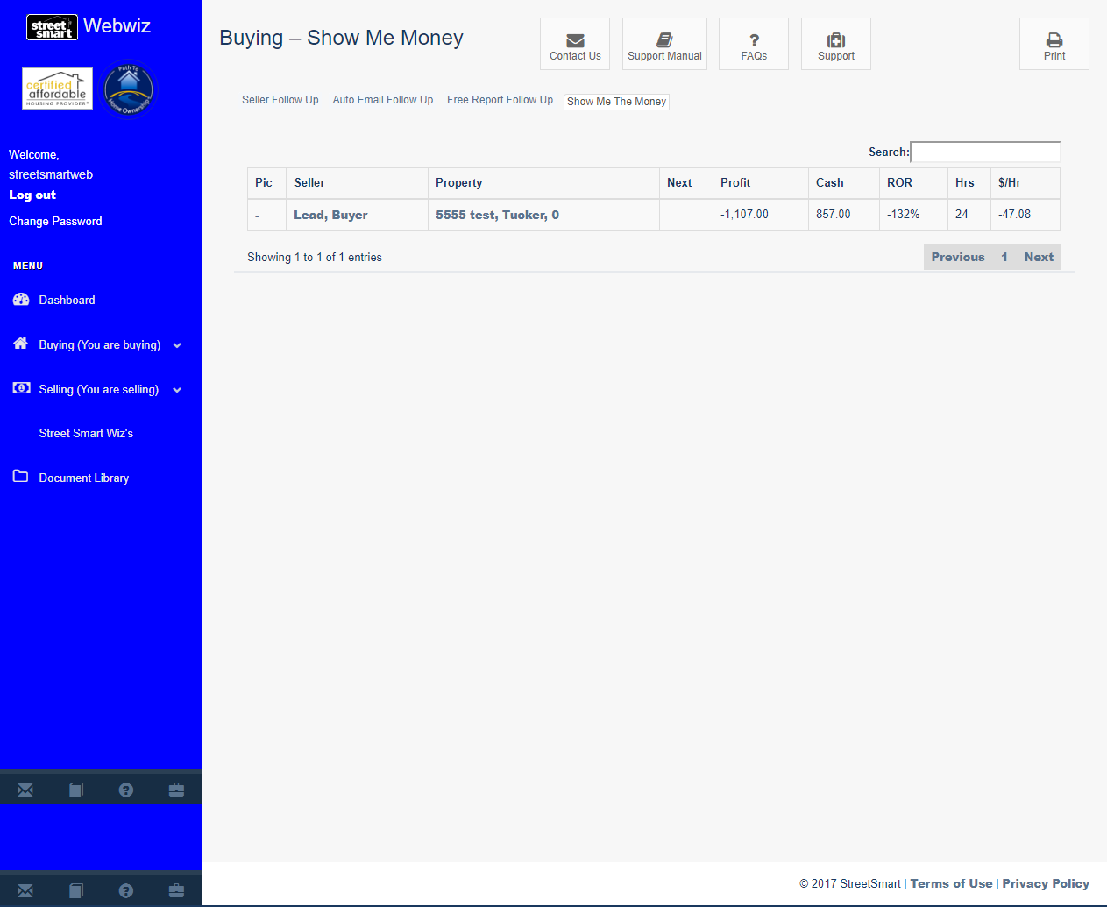
Here is another way to prioritize your deals without the clutter of the other leads. These are specific leads that you have already worked the numbers on. It has some other neat features such as allowing you to estimate the number of hours the deal will take and it calculates your earnings per hour. It also shows your Rate of Return (ROR).

Testimonials
Still working from the WebWiz™ Back Office of your buyer website, click on “Buying (You are buying)” from Main Menu” and choose “Account Management” and click on “Testimonials List” and you should see this:
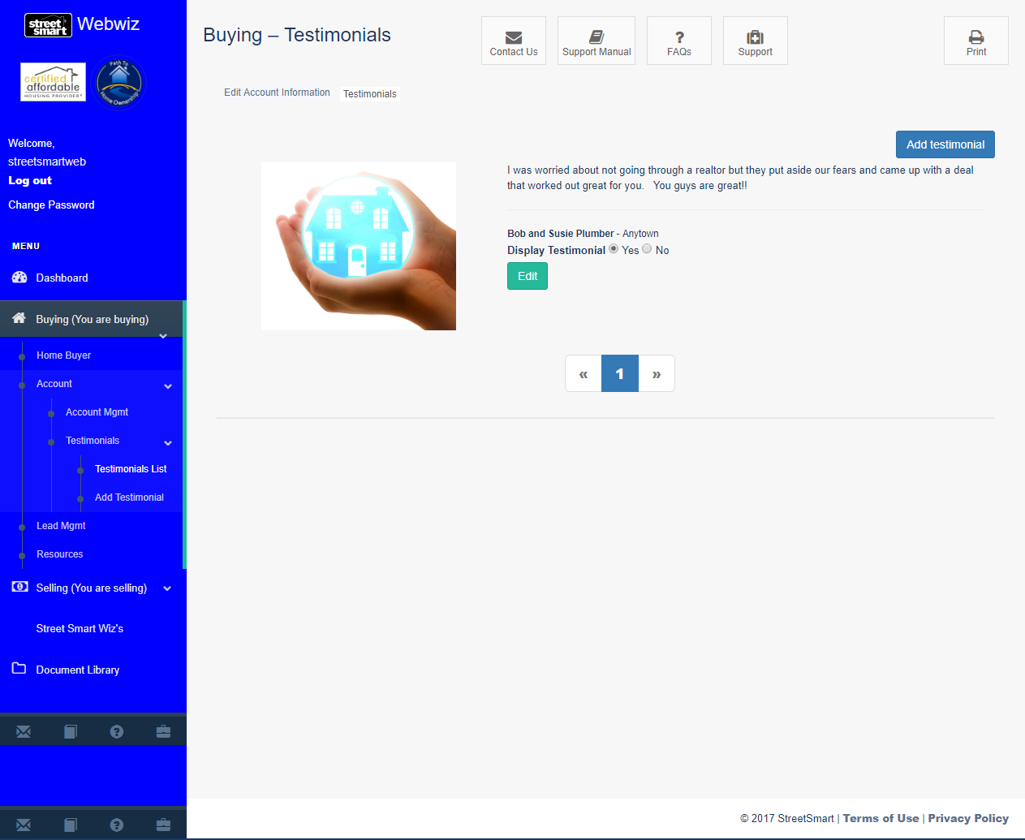
If you have more than one testimonial, then they will all be listed here.

To add a Testimonial, click on “Add Testimonial.”

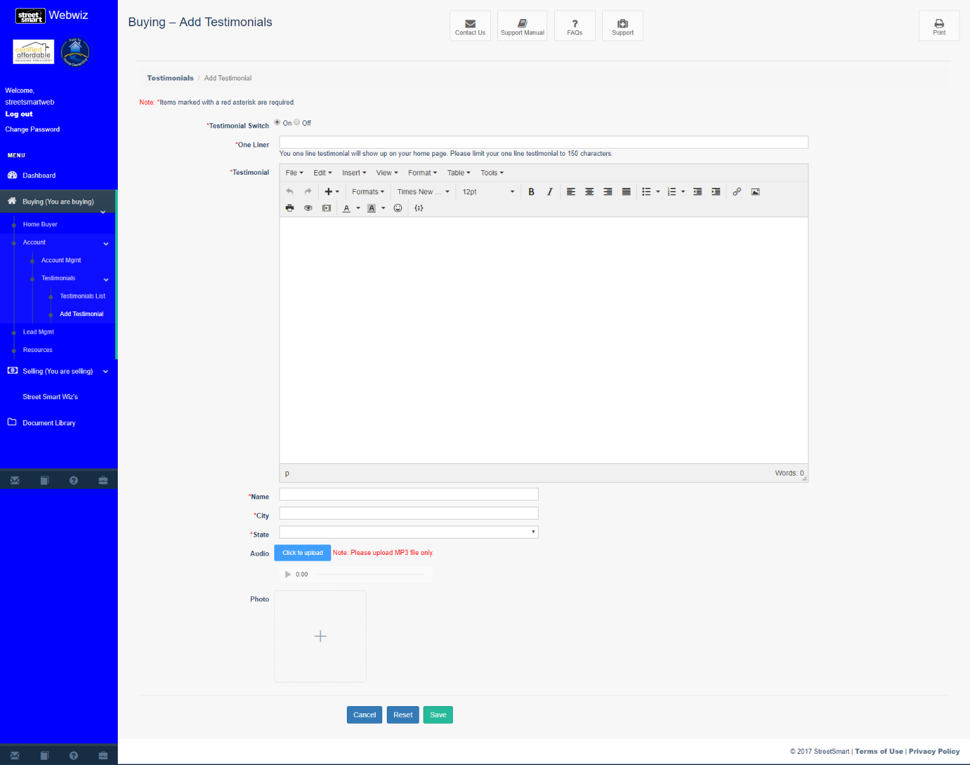

After getting to this screen, the first thing you want to do is click the “Testimonial Switch” to “ON”. If this is not clicked on, then your testimonial will not show on the public side of your site. In the One Liner field, just pull a great line from the testimonial to make viewers want to read the rest of it. In the main box named “Testimonial”, just type what your clients wrote about you then put their name and city in the fields below. You can also upload a photo of the property or of your clients. Photos of the people are very powerful.

To upload your testimonial photo, you will first need to save your photo to your computer. When you are ready to post it to your testimonial page, just click “Browse” to see this screen:
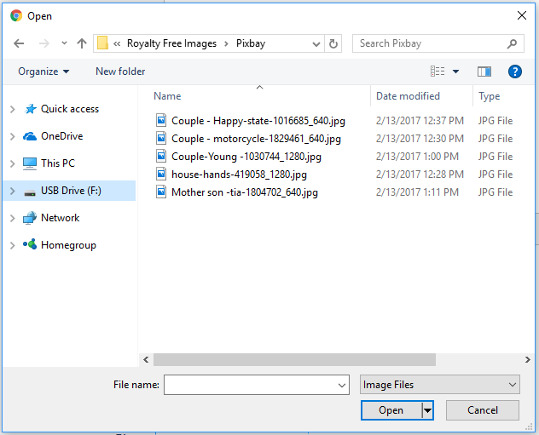
Just click on the files that you saved your picture as on your computer and click Open.
The file name automatically appears in the photo field. When you click Add, the photo automatically loads. Just confirm that the photo is saved as a JPEG or PNG image files.
Anytime you want to edit a testimonial that you already created, just click the “Edit” button, located under the photo. This looks exactly like the Add a Testimonial field with a few exceptions.
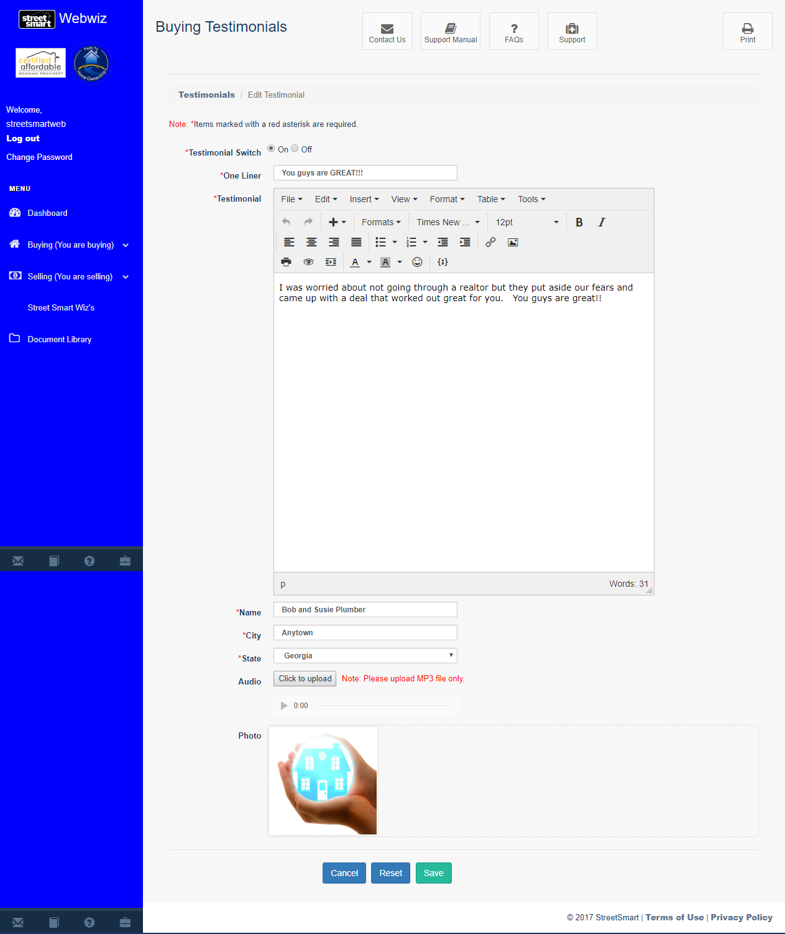
You can now view the photo that you uploaded and you are welcome to change it if you like. There is also a Reset button if you wish to discard your testimonial, but we don’t advise that. The more testimonials you have, the better! If you don’t want to delete your testimonial, but want to take it off your site, just click the Testimonial
Switch to off. This will switch off the particular testimonial, but not the rest of them.

Paperwork
Here is another GREAT benefit of having these websites. LOU’S FAMOUS REAL ESTATE PAPERWORK!!!! It’s all right here, available when you need it - accessible anytime from anywhere in the world. Just login to your WebWiz™ Back Office and click the “Document Library” link.
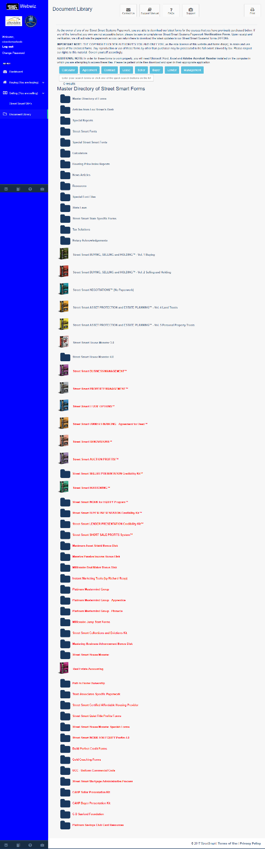
All the volumes that you own will be turned on for access. They will appear as red links and you will be connected so you can download the form that you need. As you attend the different boot camps, those links will be activated as well. If you have purchased a few volumes since you bought the website(s), to get the corresponding links activated, just click the Verification Form link and select the links you would like activated. If you are missing any of these systems, you need them! This is all part of our franchise approach to assure your success in this business. Just email Support@StreetSmartInvestorWebsites.Com or call 1-800-578-8580 for special pricing to complete your success system.

Free Report
The Free Report is also available for your Selling website. Please reference page 35 for details on this feature.

Other Bonuses
On your WebWiz™ Main Menu, left-side of your BackOffice, you will find some other links: Renovation Cost, Cost to Sell, Offers & Deals. These links can be found by clicking on “Resources.” The reference pages help you calculate the costs to do a deal as well as some of Lou’s suggested deals and exit strategies. A quick reference guide if you will. Primarily your websites are a credibility and management tool.

Help Desk
Please reference page 37 for details on this feature.

Your Street Smart® Investor Selling Website Tutorial
If you are already in the WebWiz™ Back Office of your buyer site, just click on “Selling (You are selling)” and choose “Home Seller” link you’ll find at the left on any page. You should see this:
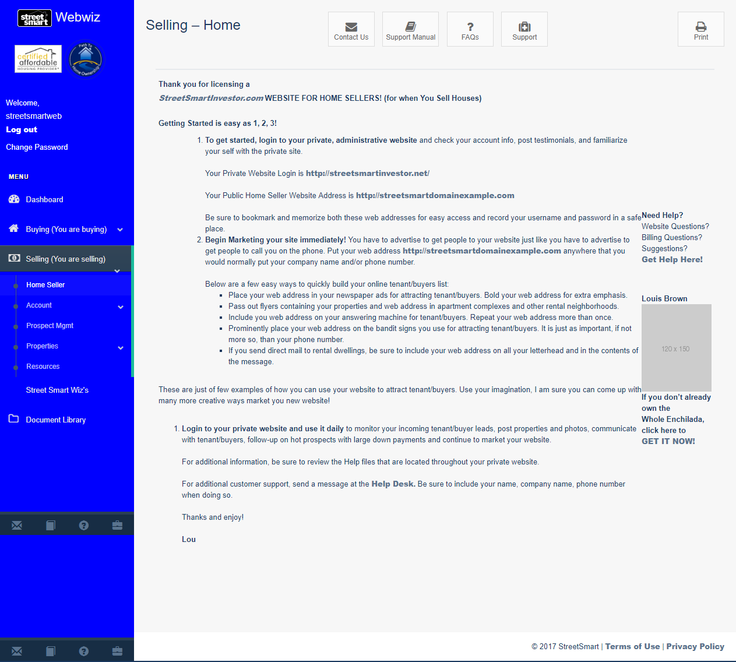
It looks familiar, doesn’t it? That’s one of our best features – you don’t have to learn a whole new system for your selling back office. It is set up in a similar way as your Buying websites.
The “Account Management” is the exact same as the buying website (reference page 6), just make sure you change the information on each site because changes on one do not affect your other sites.
If you click the “Prospect Management” link, you should see this screen:

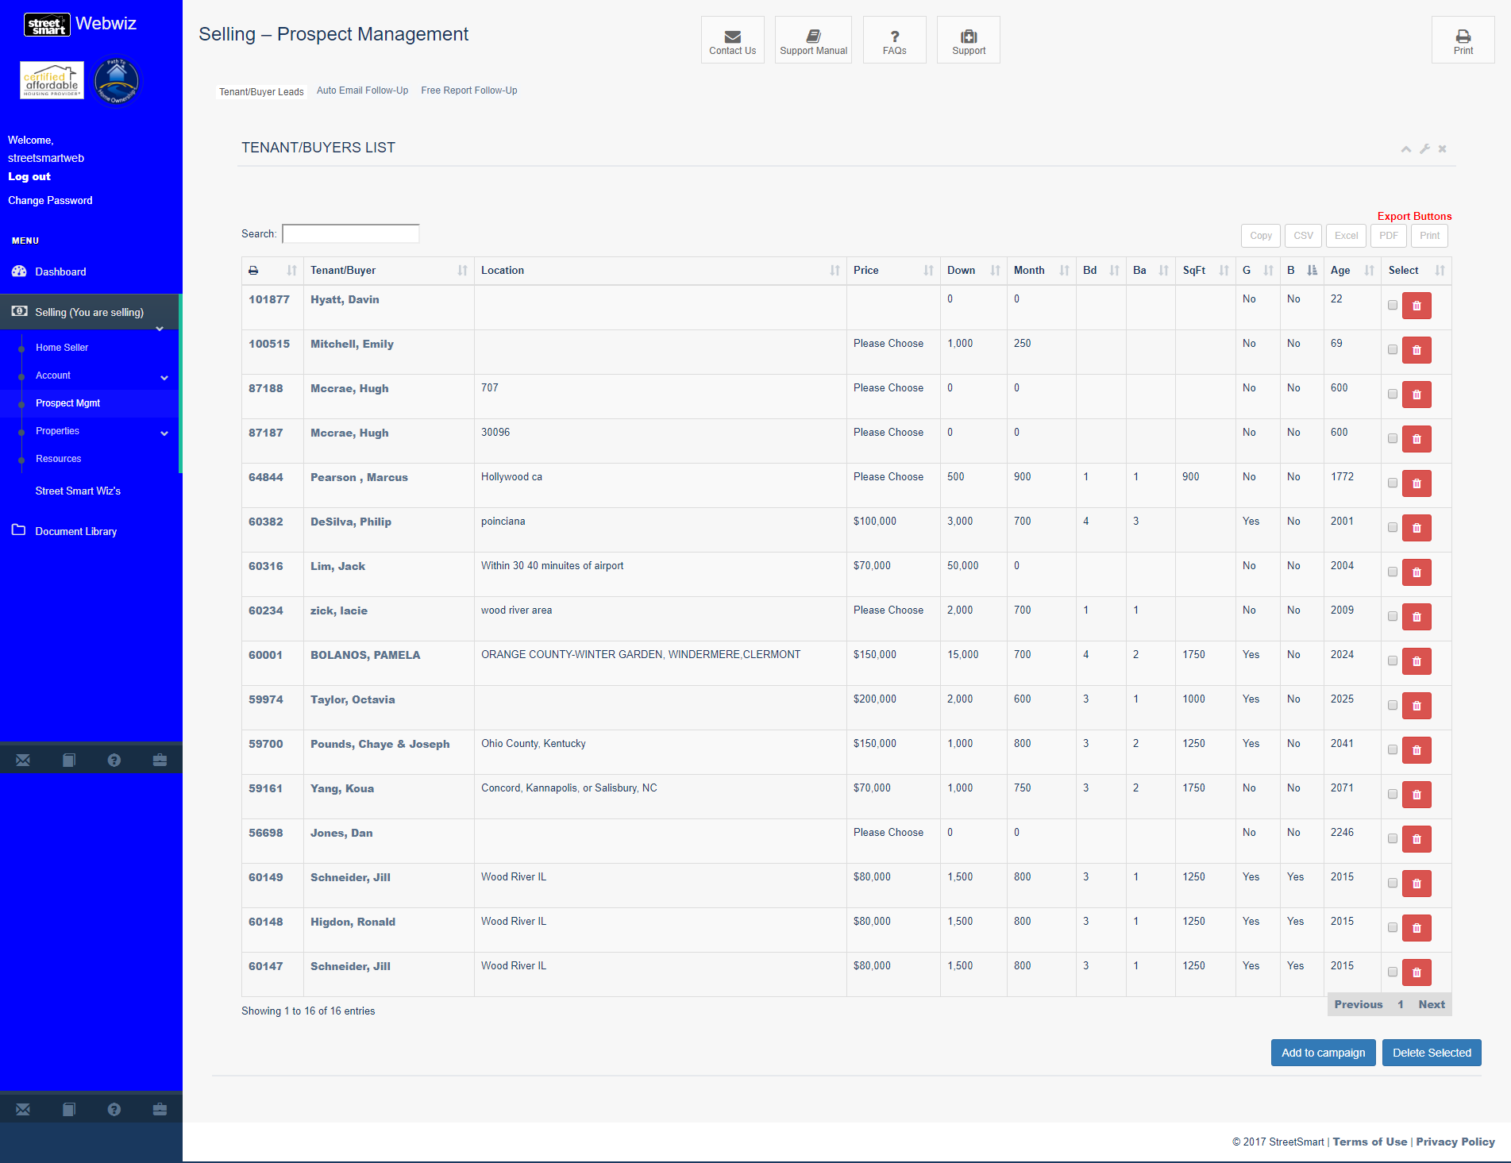

The system allows you to maintain a database of Buyers or Renters specific to renting apartments or renting or buying houses. Those who submit an application to buy or rent appear here. So now you are collecting information on the kind of house or apartment they are looking for and what they can afford. The numbers on this screen show the highest amount they say they can afford.

When you click on their name, you will see the detailed Tenant/Buyer Questionnaire form with all their answers:

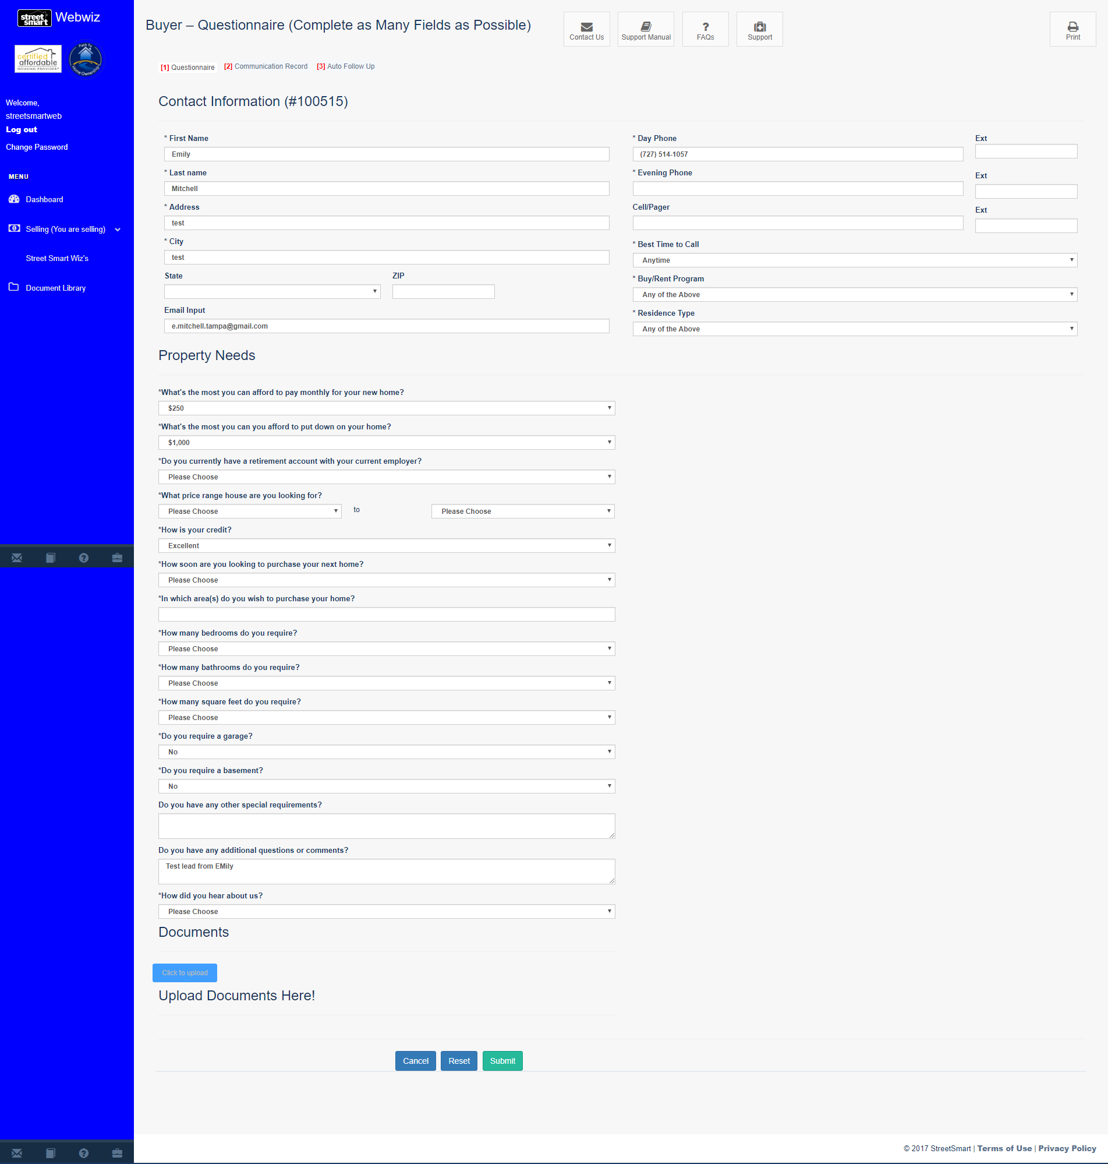

As with the seller questionnaire, when talking with these prospects you can adjust the numbers accordingly and click “Submit” to save the changes.

From the Questionnaire form you can click “[2] Communications Record” and you’ll see:
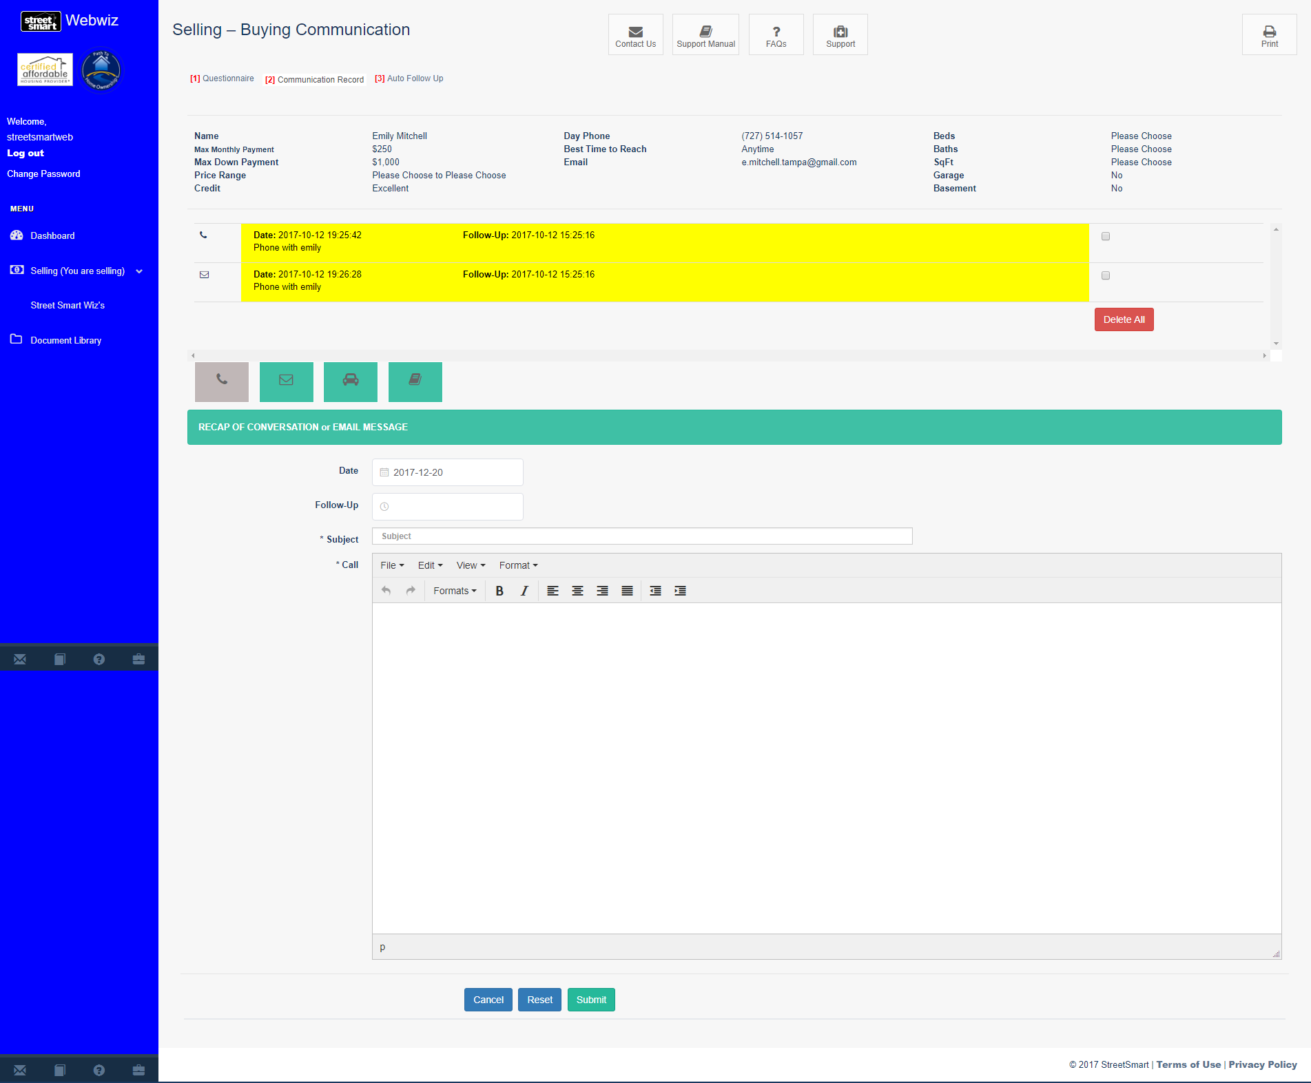
As you can see, you have the Buyer’s information at the top of the screen which has been automatically loaded by your system. This feature allows you to track communications and set follow-up dates. As in the Buy Site, you can send email directly from this screen by clicking on the envelop icon. This allows you to follow up 24/7 with all your prospects.
Imagine having office staff who can do this for you. This will allow them to be much more efficient in handling this important income producing part of your business. In the MPI (Massive Passive Income) training we show you how to market to build a buyers list. Imagine already having buyers and renters lined up before you buy. This will allow you to buy with confidence because you won’t have the fear of holding the property.

Properties
Now it’s time to load the details of any of your vacancies. You’ll also do this when you place any property under contract to buy or after you close on it.
To Add a Property, click on “Selling (You are selling), select “Properties” and finally choose “Add Property” from anywhere on your WebWiz™ Back Office’s Main Menu. You should see this screen:

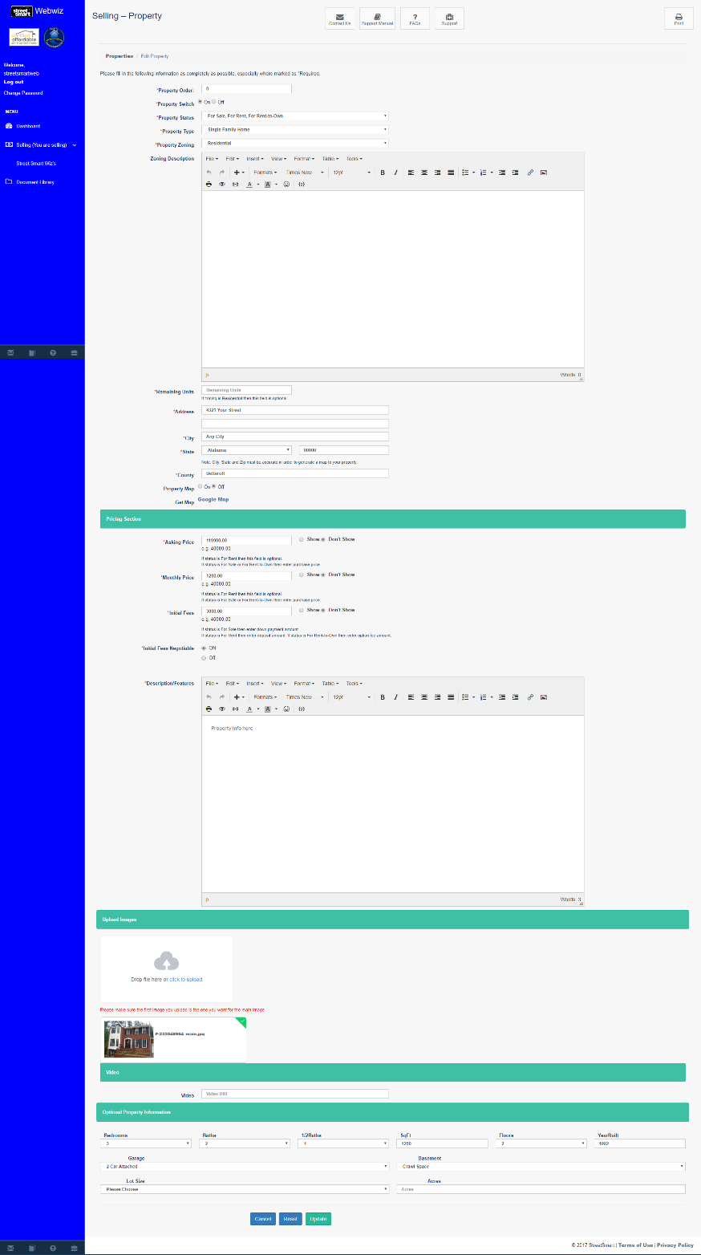
Just fill out the information and continue by filling out the required fields. Before uploading a photo, make sure there are no dollar signs or commas in the numbers field when filling out the numbers; otherwise the system protects you from making a mistake and won’t allow you to move on.

Scroll towards the bottom of the page, this where you can upload photos of each of your properties.

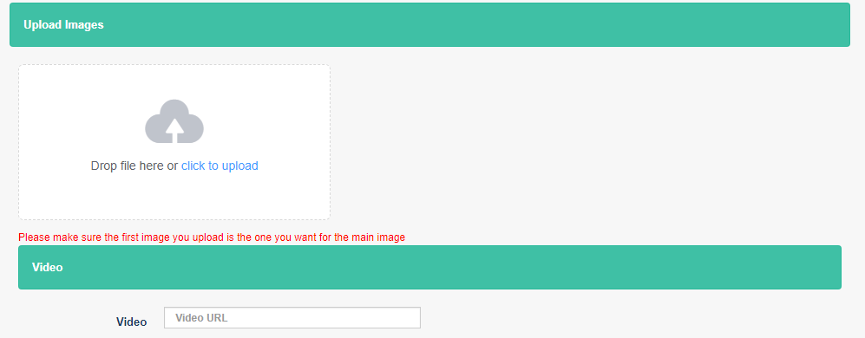
Helpful Photo Uploader Guidelines:
- To upload a photo or multiple photos, you must first create the photos using a scanner, digital camera or smart phone. Next, save the photos to your computer’s hard drive.
- When labeling or creating file names for your photos, DO NOT use zeros, spaces or special characters. An example of a proper photo file name would be 123EMain.jpg
- There is no limit to size or amount of photos you can have per property.
- First photo uploaded is known as “Main Photo” and a thumbnail of that image will automatically appear in ‘Available Properties,’ the public side of your Selling website.
- PLEASE BE PATIENT while your photos are being uploaded and processed. It may take several minutes to complete depending on the file size of the photos being uploaded.
- Once all photos are uploaded, please review thumbnails and sort through the images by drag and drop.
- Once satisfied with images, click on Submit button.

First, you will need to upload property photos to your computer. Once that’s done, launch the “click to upload” link to browse and locate the photo file on your computer. If you don’t have any photos at this time, or you are going to put more up but haven’t taken them yet, that’s okay. You can always add more photos later. If you don’t load any photos the website simply shows “no photo available” until you upload photos.

From here, click “Properties Management” to view list of properties. This will transfer you to a similar page which look like this:

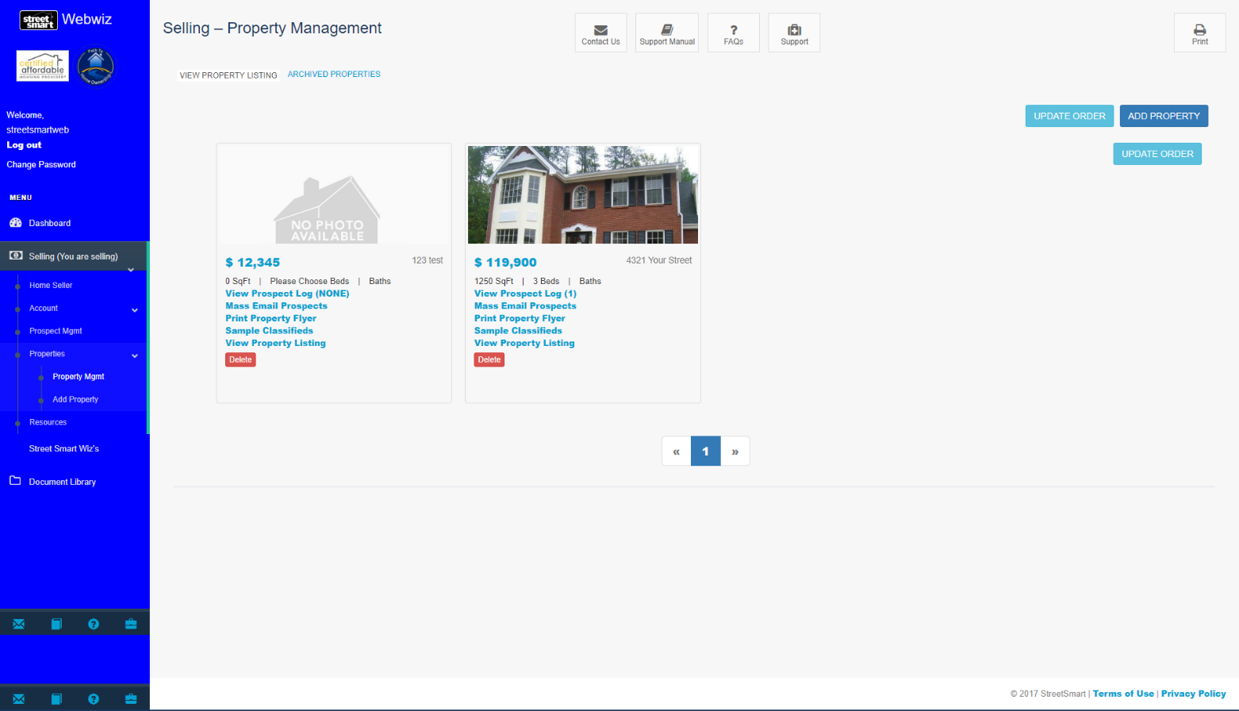
Helpful Property Management Guidelines:
- To Add a property, click on “Add Property” button
- To Edit a property, click on thumbnail of Main Photo for desired property
- Active Properties are displayed under, “View Property Listing”
- Archive Properties, click on desired property and turn “Property Switch” to off
- Update Order of properties:
  - Click and hold onto property
  - Drag and drop to desired place
  - Click on “Update Order” button to save new property order
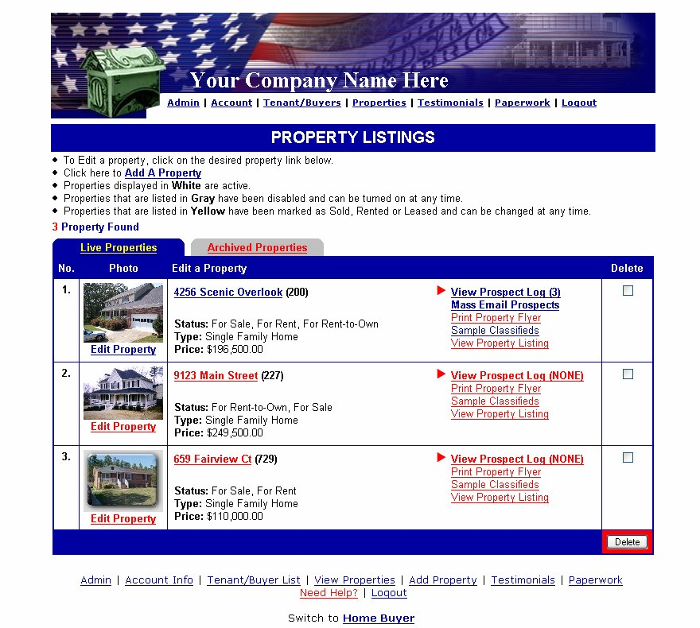

Since we just added a property, you will find it under the “Archived Properties” tab. These are the properties loaded to the system that are not activated live on your public selling/renting website.
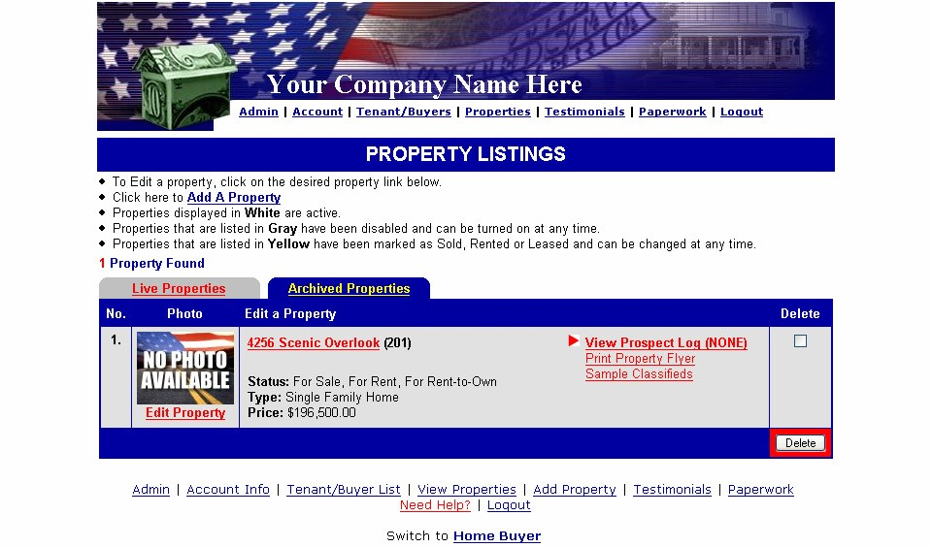

This is a great feature as it allows you to store all of your rental, lease option and owner financing (agreement for deed) properties. When your active properties are rented or sold or lease optioned or sold with owner financing you will merely click the “Property Switch” to “Off” and the property information will disappear from your active selling/renting website, but will be stored until the property comes available again. When it does, you’ll merely click the “Property Switch” to “On”, change the details such as price and terms and it will once again be active on your site, allowing you to compare it to your buyers list, send emails, make calls, etc and “put it to bed” again real soon. Are you starting to feel like you’ve got a silent partner who is going to make your life a lot easier? You should because that’s what this will do for you.
***To make a property live on the public selling/renting website, click on the “Edit Property” link. You should see this:

Let’s take a look at how to edit our properties. First, if you want to create marketing for a particular property you may want to include a property ID code so prospects can go directly to details about that property rather than navigate the entire site.

The “Property Switch” is located right under the “Property ID”.
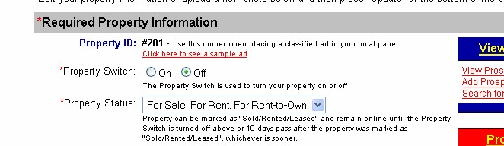

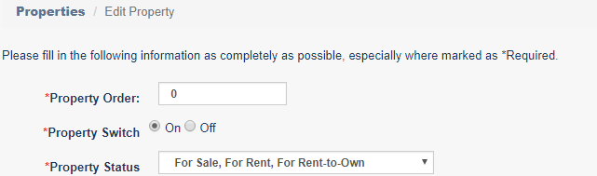
Turn the switch “ON” to have your property show on your public website.

Now, let’s take a look at the “Print Flyer” link:
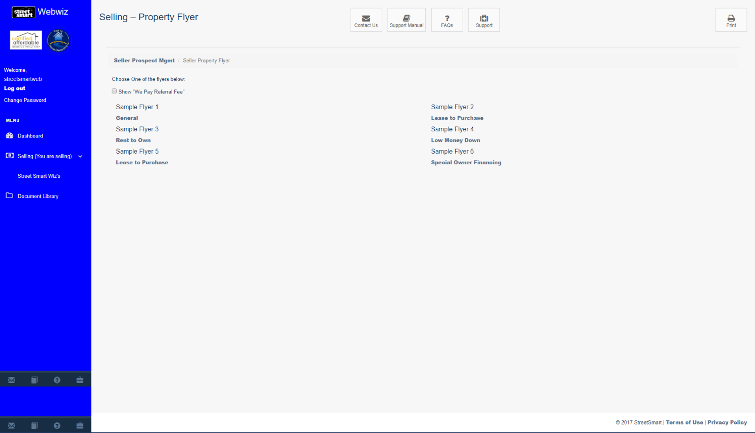

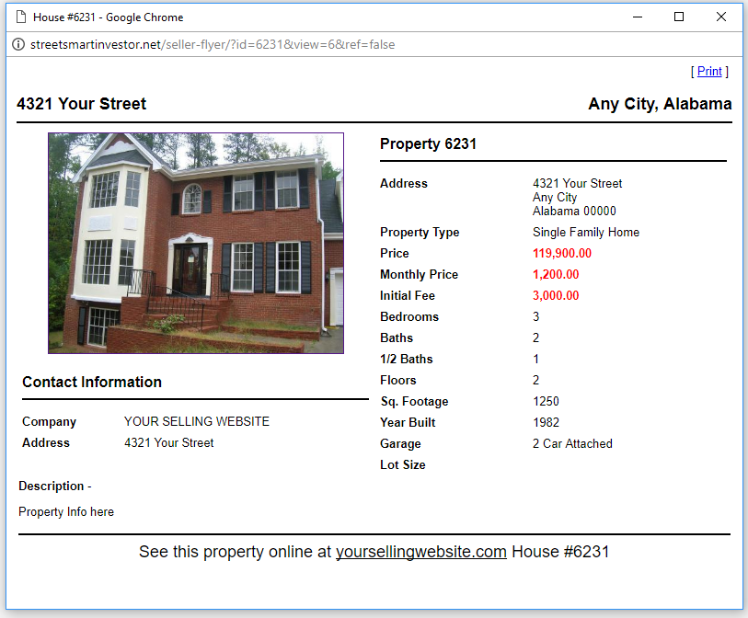

WOW!! The website actually creates a detail flyer for your house using the information you previously uploaded. No need to spend time formatting and designing your grab and go flyer. All you have to do is print one out and run to Kinko’s, or print out the quantity right in your office! Is that a time saver or what?!

When you close that window, on the same line, click “Sample Classifieds”.

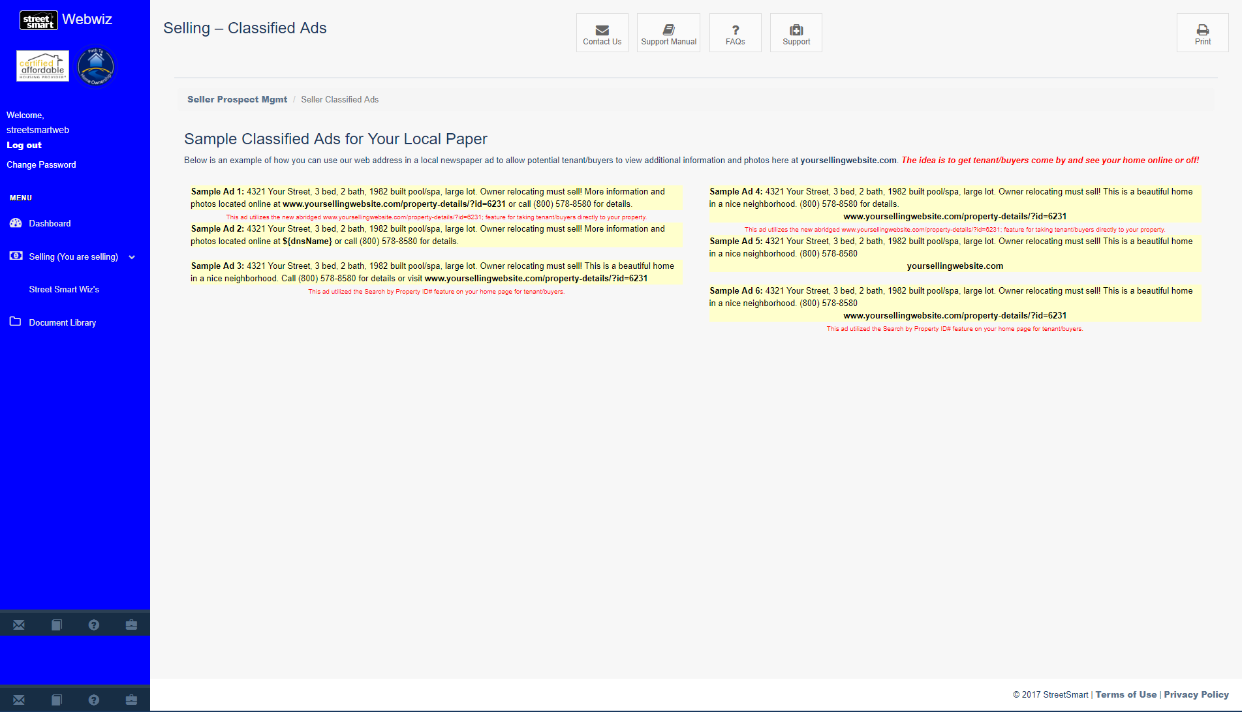

Here are six sample ads already designed for your property. All you have to do is copy and paste into an email to your local newspaper. How great is that?! You are spending minimal time on figuring out what your ad should say. Once you paste the ad, of course you can alter the ad if you choose.

Another great feature is the “Prospect Log”. Here is where you can attach certain buyers/tenants to a particular property. Click on the “View Prospect Log” to begin.
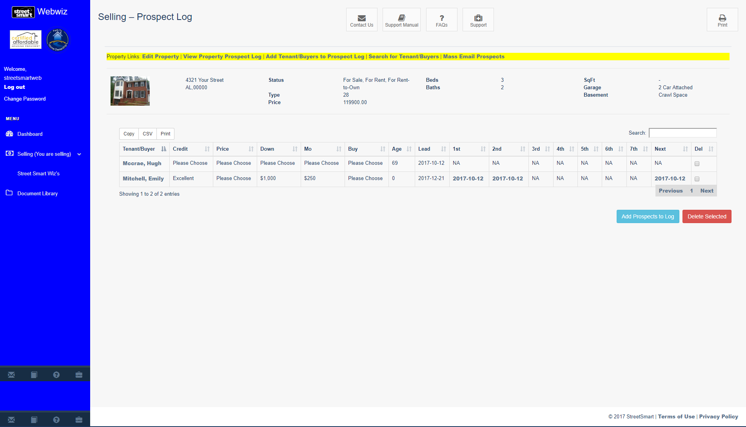

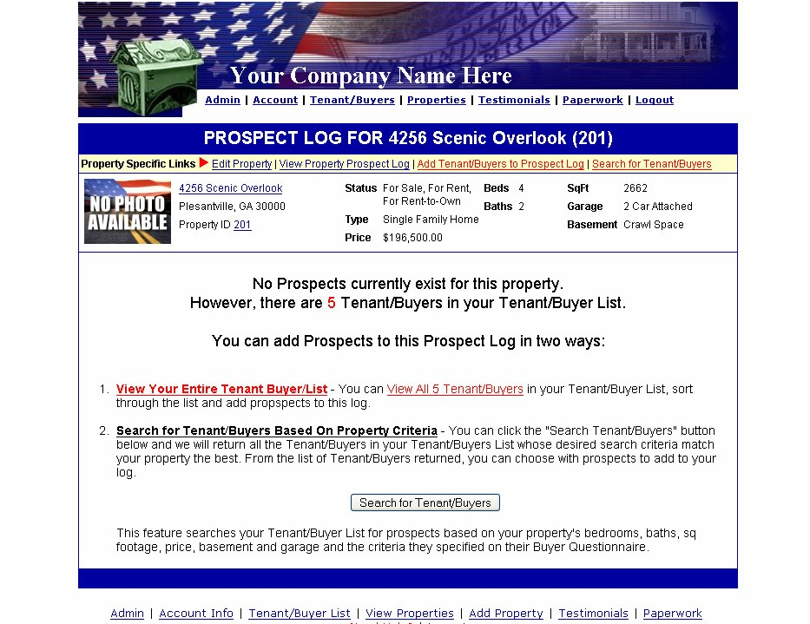

You see that your property information stays at the top of the screen. This helps if you choose the manual selection of buyers/tenants as you can see there are two ways to add people to this particular property:
- View Property Prospect Log - You can view all tenant/buyers in your Tenant/Buyer List, sort through the list and add prospects to this log.
- Search for Tenant/Buyers – This is a special auto search to make moving your properties effortless and quick. Simply click the
"Search Tenant/Buyers" link. That will show all the Tenant/Buyers in your Tenant/Buyers List whose desired search criteria match your property the best. From this list of Tenant/Buyers, you can choose which prospects to add to this property’s log. This is your “target market” to offer the subject property to.
If you chose the first method to view the entire list, your screen should look like this:
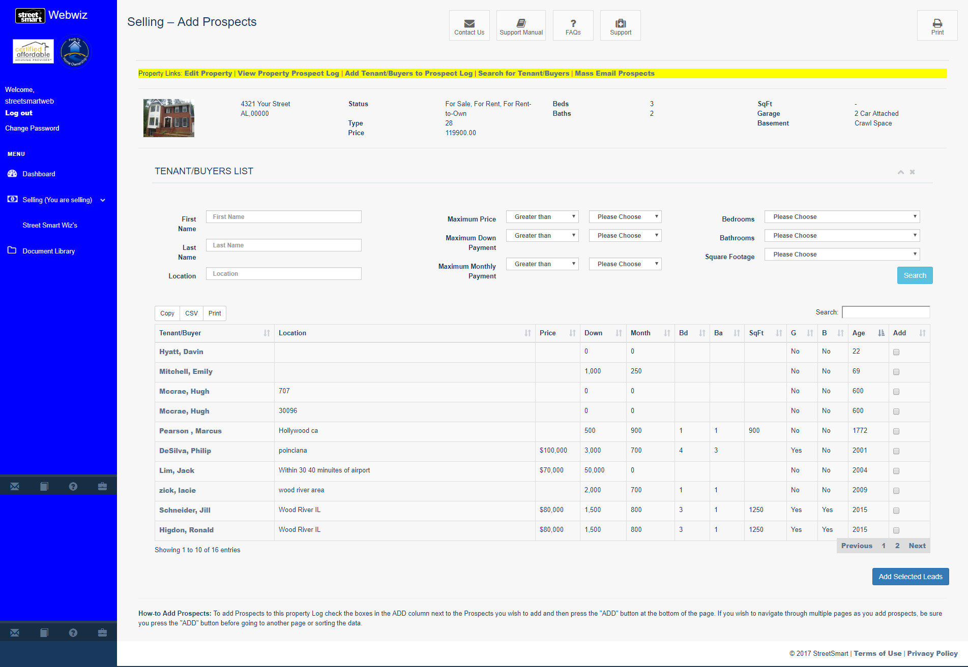
As you can see, by clicking on “Search Tenant/Buyer List”, this brings up your entire list. All you have to do is check the names on the far right and click “Add Selected Leads.”

Once this occurs you now have created your target list.
Any buyers who fall within your specified price range, would now appear. As with the prior screen, all you need to do is check the name on the far right and click “Add”.
Whichever method you used, after clicking “Add”, click the “View Property Prospect Log” link in the yellow bar located right above the property information. You should now see this:

Here you can see who from your entire list appears to be a good match and follow up with communication. Be sure to log these communications in your Tenant/Buyer Communications Log discussed earlier. If you accidentally added someone that you didn’t mean to, just click the box on the far right and click “Delete”.
One of the most favorite features on this website is on this page. Click the “Mass Email Prospects” link on the far right above the Next and Del columns.

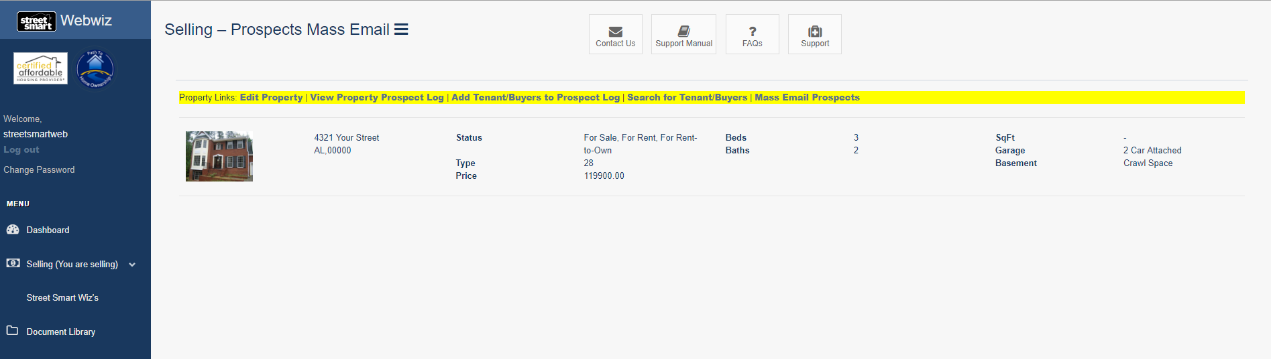

Here you’ll be able to send a general email blast to everyone. It can be a blast with this specific property listing attached, or it can be a blast with all your property listings. You can exclude any emails already attached to this property and/or add emails to include that will be sent to everyone at the same time. No more individual emails are necessary. They are all saved right here on the site for you! The best part is, no one can see who else you emailed your open house information to. What a time saver! This will help you build your business faster and better allowing you to get a profitable transaction right away.
Testimonials
Please reference page 17 for details on this feature.
Statistics
Please see “Other Bonuses” on page 21 for details on this feature.

Free Report
Some of you want the added feature of further marketing your company or more detail about particular programs you offered. So we created the Free Report option just for that.
Going back to the WebWiz™ Navigation Menu, click on either Buying Lead Mgmt or Selling Prospect Mgmt. Click on “Free Report Follow-up,” found at top of page.

Now, navigate to the bottom of Free Report Follow-up page and click on “Manage Free Reports” button. This is where you upload and manage your reports. Here’s how:
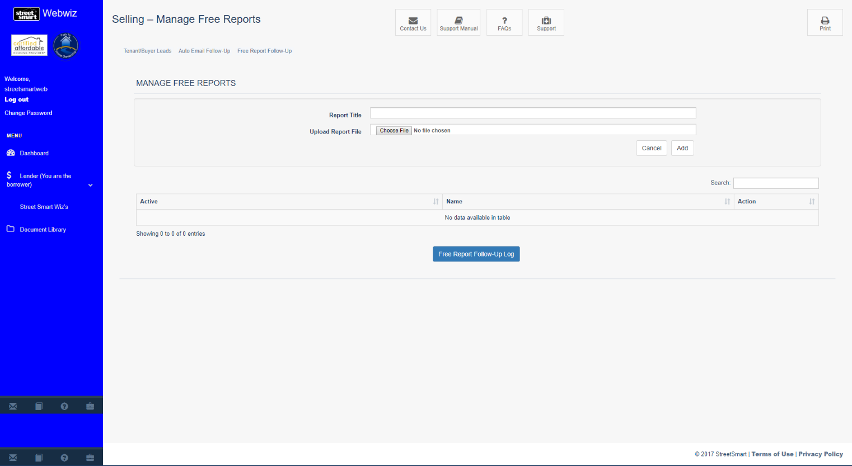
Write or find your special report. Give the Report a short title on your computer and then click “Browse” to find the file to upload. Once you have located the file and clicked “Open”, click “Add”. You should now see the report. Check the box on the far left and click “Assign” to allow public users access to see your special report.

Once prospects download your free report, you have a special database to use to follow up with these important new additions to your buyers/renters list as well as your sellers list. The “Free Report” follow up will look like this:
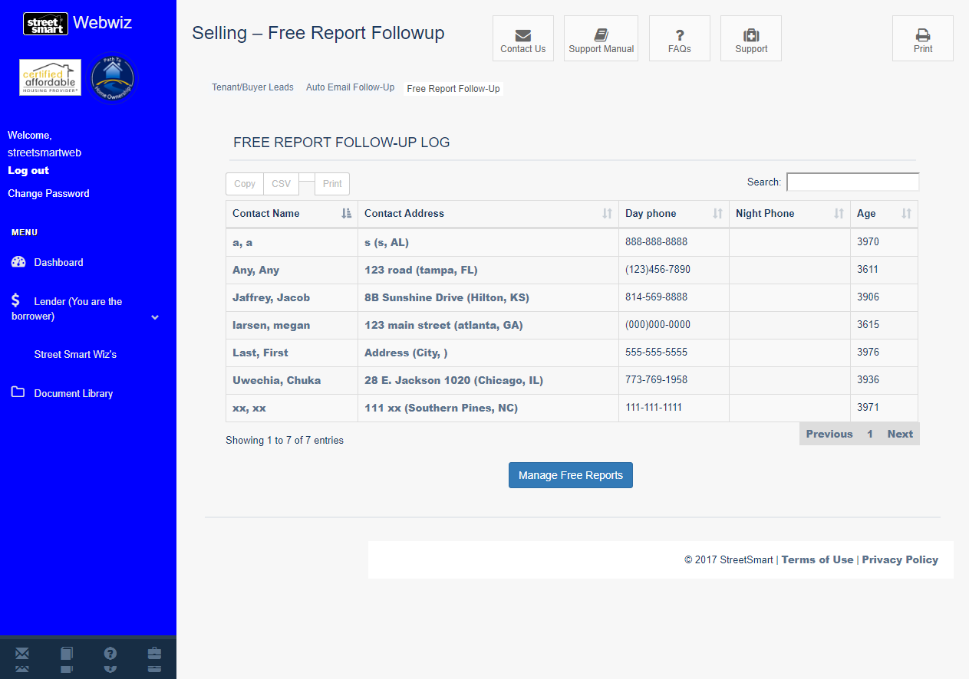

When you click on their name, you will see the prospects contact information they provided when ordering the report:
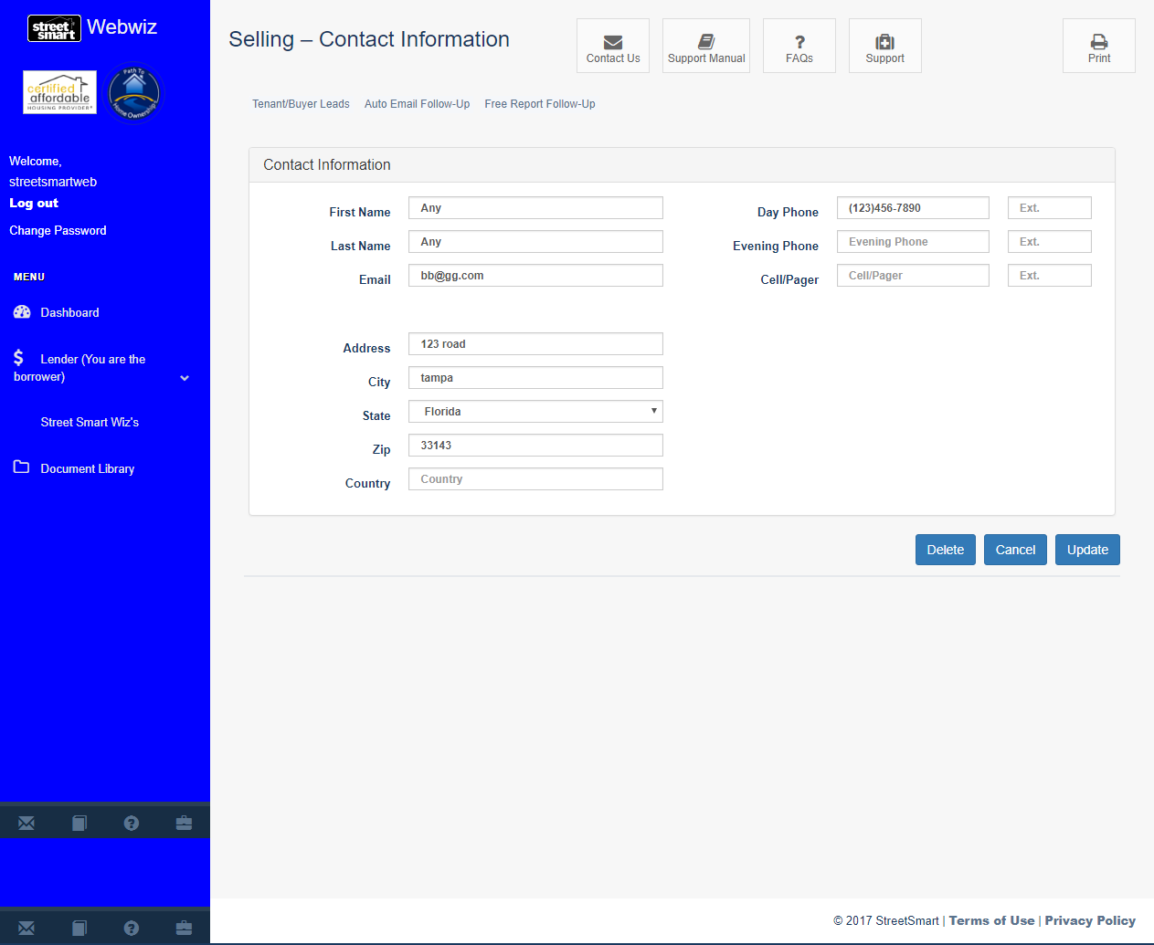

Help Desk
If you have any questions, or need help with something, you can email us directly at Support@StreetSmartInvestorWebsites.Com or you can click the “Contact Us” icon from anywhere from your WebWiz™ site. Here is the screen you will see:

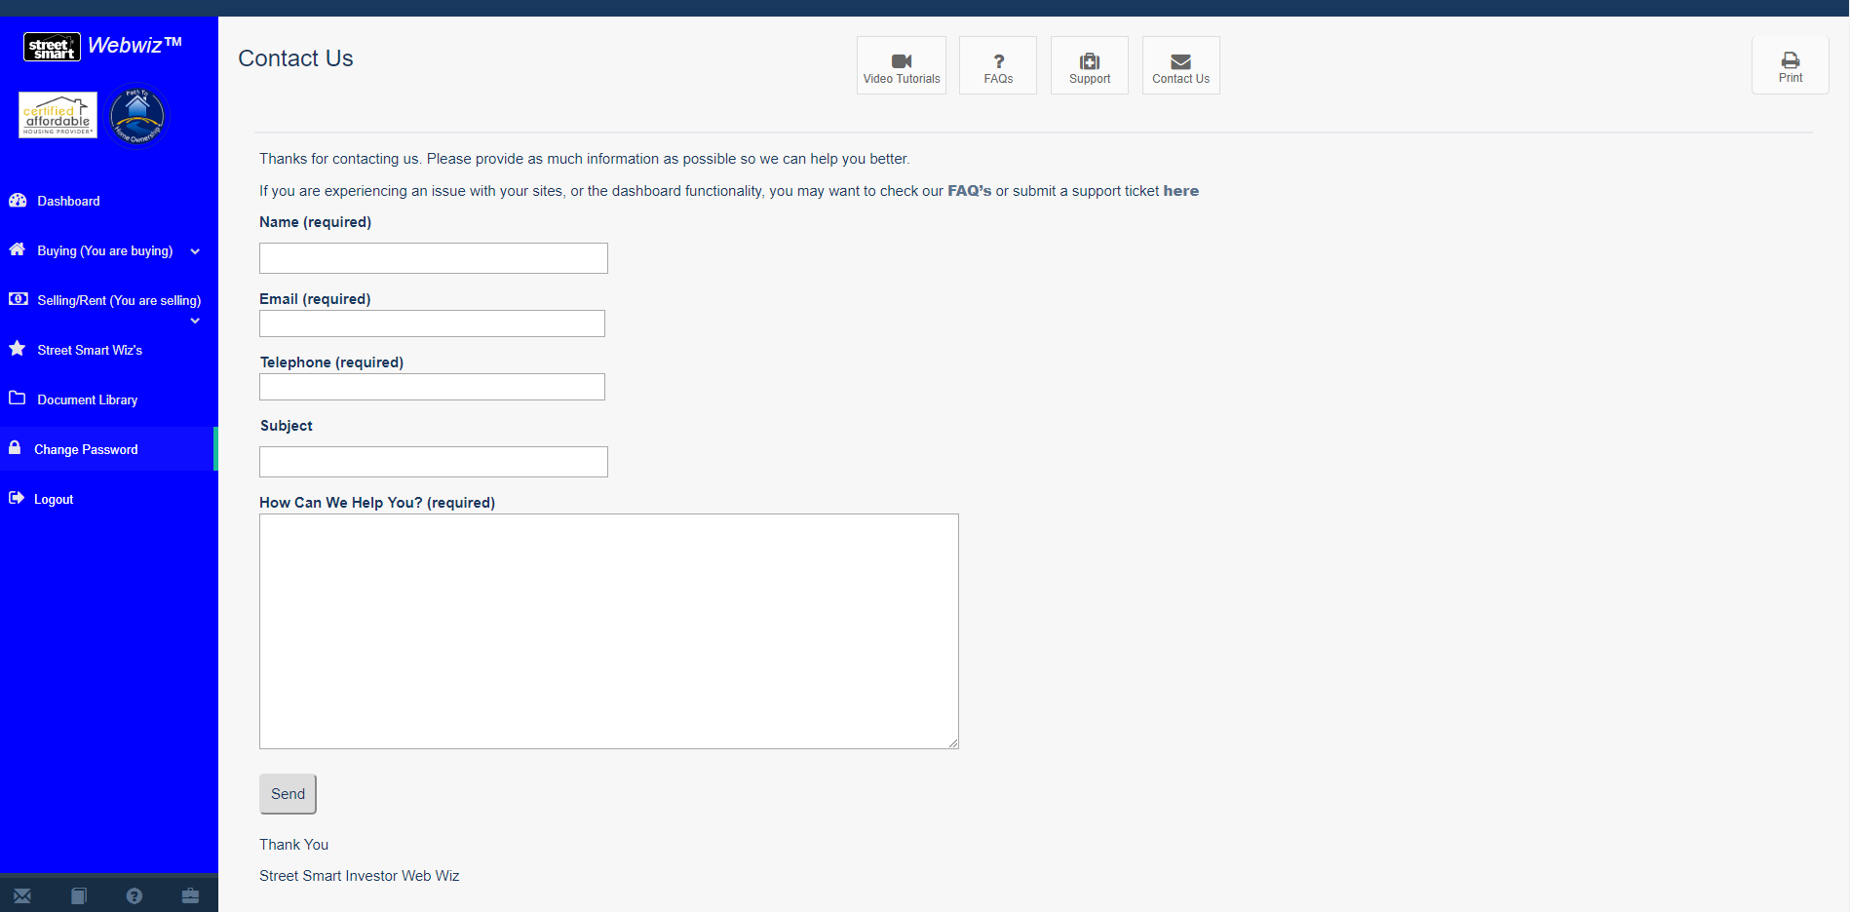
Simply, fill out the required fields form as if you were writing an email. Just click on “Send” button and we will respond promptly with your answer.

Congratulations! You’re ready to profit with your Street Smart® Investor Websites!
As we’re sure you’ll agree, these business tools are well thought through and are very user friendly. Designed by investors for investors, these sites use the copyrighted system of Louis “Lou” Brown. You’ve probably recognized that many of the paper systems included in your written volumes have come to life in these Buying and Selling Websites.
As you can see, we’ve helped you use your Tools in conjunction with our Technology to help you build your business faster, safer and for much less cost than if you tried to design it on your own.
But we didn’t stop there. SpanishWiz™ – We’ve also translated your Buyer site and your Selling/Renting site into Spanish. Once you pay a small one-time fee, any of your prospects can press one button and instantly see the entire site converted into Spanish! Finally a way to tap into a very lucrative market for you that your competition is ignoring!
But we didn’t stop there. Many of you recognize the need for private money for your business. We brought your “Lender Presentation Kit” to life by developing a website where you can send prospective lenders to check you out and see more about possible plans you have to offer.
But we didn’t stop there. VoiceWiz™ Automated was added to provide an automated voice answering solution that allows you to capture telephone numbers of callers and do many other features such as receiving faxes. It provides your own 1800 toll free number with zero cost per call or per minute, unlimited for Street Smart® clients. We also offer prerecorded scripts and a pre designed voicemail box layout with an unlimited number of voicemail boxes all automated.
But we didn’t stop there. VoiceWiz™Live – after getting questions answered by the automated system your lead can click anytime to go to a trained live operator who can go to your website and fill out your questionnaire immediately. Instantly emailing the lead to you or contacting you directly depending on your wishes. Imagine having an office assistant without hiring an employee.
But we didn’t stop there. CompWiz™ – Finally you have at your fingertips a solution to determining the value of your property lead. Use what the pros, such as appraisers use. Find out the courthouse data, square footage, proximity to your subject property, hazardous waste sites, flood plain, and all the sold comparables, pricing, values per square foot, and a lot more. For a low monthly fee you can comp as many properties as you need to, and just about anywhere in the country. Just click the “CompWiz” button for more details.
But we didn’t stop there. MailWiz™ – You don’t want to obtain mail lists, choose marketing material, get stamps, handwrite envelopes, or deal with the post office. So, we’ll do it for you! That’s right! You’ll be able to have your letters, post cards, flyers, and newsletters done for you. You can even take advantage of our copyrighted marketing material available through our service. You can pay by the piece or by the package. Just click the “MailWiz” button for more details.
But we didn’t stop there. SignWiz™ – All your off site marketing is handled by
MailWiz™. Your onsite marketing is handled by SignWiz™ . Signs, Banners, Door Hangers, Post It Notes, Business Cards. You name it, one stop shopping, and for a fantastic price you can order small quantities or order a package for the best deal. Check out our distinctive copyrighted designs that get results. Just click the “SignWiz” button for more details.
But we didn’t stop there. FindWiz™ – When you find a house, but can’t find the owner, don’t let these great no competition deals slip away. Our Private Eye firm can help for just pennies vs. what you would spend to do it yourself. Just click the “FindWiz” button for more details.
But we didn’t stop there. CashWiz™ – Money for your deals. Whether you need a partner, a private money loan, or traditional financing we’ve got your connection right here. Just click on the “CashWiz” button for more details.
But we didn’t stop there. WarrantyWiz™ – Create comfort for your buyers by offering a Home Owner’s Warranty or selling it to them. Free for your vacant properties- you only pay when either you or your client buy the extended coverage.
But we didn’t stop there. InsuranceWiz™ – Solve your vacancy and builder’s risk headaches with this affordable source that offers what you need for all your projects.
But we didn’t stop there. LockWiz™ – No need to change the entire doorknob when you can use a specially designed key that allows you to change just the cylinder. Once you’ve changed over to these super strong locks your lock worries are over. You’ll be able to have a master key for all your properties. You’ll also need lock boxes for your properties to follow the Street Smart® system of low headache property management. All at prices well below retail. Click LockWiz™ for details on this unmatched sanity tool.
But we didn’t stop there. CreditWiz™ – Imagine being able to clean foreclosures, bankruptcies, and other derogatory entries off your credit report. You’ll also be able to use this service to clean the credit of your sellers and your buyers. The sellers get a real reason to work with you. With credit repair your buyers can qualify to buy your property putting money in your pocket a lot quicker. Click CreditWiz™ to order this vital service.
But we didn’t stop there. ShortWiz™ – Avoid the pain and suffering of doing Short Sales yourself with this great service. You’ll have a law firm who specializes in doing short sales and workouts at a very affordable price. Focus on your core business and let pros handle the hassles of follow up, negotiating, and getting agreement on your Short Sales. Click ShortWiz™ for all the details.
To upgrade your system to add Spanish translation, your own lender presentation website, and our CompWiz™, VoiceWiz™, MailWiz™, SignWiz™, FindWiz™, CashWiz™, WarrantyWiz™, InsuranceWiz™, LockWiz™, CreditWiz™, or ShortWiz™ call 1-800-578-8580 or email us at Support@StreetSmartInvestorWebsites.Com
Oh, and we haven’t stopped there either. Continue to watch in the weeks and months ahead as we tweak and refine your websites to make them easier and more convenient to use. Many of these upgrades won’t cost you anything additional. Major upgrades that you’ll love will be offered to you at preferred pricing.
Our goal is to provide you with a totally automated solution for your great real estate business all at a very affordable price. We intend to earn your respect, support, referrals, and loyalty as we continue to partner with you in the development of your business. Thank you for your business!
Your feedback is always welcome and much appreciated. We appreciate your testimonial in how the sites have worked for you as well.
To your wealth!
Louis “Lou” Brown and the entire team at Street Smart® Investor Websites

